Appendix B: Full, Itemized List of Evidence

Table of Contents

allyable 3

Evidence from Website 3

Evidence from Twitter 4

accessiBe 9

Evidence from Website 9

Evidence from E-mail 12

Evidence from Twitter 12

Evidence from Facebook 13

Evidence from LinkedIn 18

Evidence from Google Ads (source: SpyFu.com) 19

Evidence of other anti-competitive behavior 20

Evidence that accessiBe’s solution does not live up to its promises 21

Accessus.ai 22

Evidence from Website 22

ActiveIntent 27

Evidence from Website 27

AudioEye 28

Evidence from Website 28

Evidence from Twitter 28

Evidence from Google Ads (source: SpyFu.com) 29

EqualWeb 31

Evidence from Website 32

Evidence from Twitter 34

Evidence from Facebook 39

Evidence from Google Ads (source: SpyFu.com) 40

Max Access (by Online ADA) 42

Evidence from Website 42

Evidence from Facebook 44

Evidence from Google Ads (source: SpyFu.com) 45

Purple Lens 47

Evidence from Website 48

UserWay 48

Evidence from Website 49

Evidence from Email 52

Evidence from Twitter 53

Evidence from Facebook 54

Evidence from Google Ads (source: SpyFu.com) 59

Evidence of other anti-competitive behavior 61

# allyable

“Allyable creates software to make digital accessibility easier and faster for site owners. Our award-winning technology reduces the cost and complexity typically associated with making websites compliant with accessibility laws and guidelines.” (<https://www.facebook.com/allyablesoftware/>)

Address: 1410 N 31st St, Philadelphia, PA 19147

Website: <https://allyable.com>

## Evidence from Website

The company claims to “fix” accessibility violations in real time:

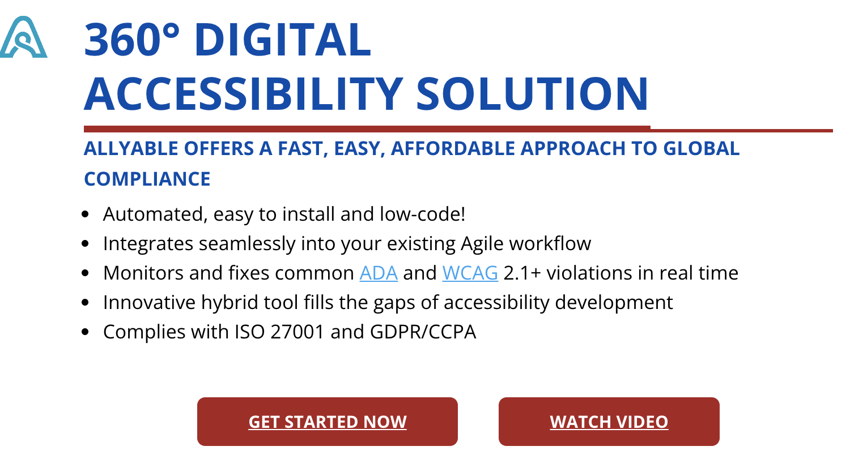

Figure : 360° Digital Accessibility Solution (Captured on October 21, 2021)

The company’s FAQ claims that their product offers, “immediate remediation, continuous compliance, and built-in accessibility for existing digital content and assets in development,”:

![First, let us applaud you for choosing to build or update your website and other digital assets to be fully inclusive for all potential users, including the 1.85 billion people worldwide who live with disabilities. With 98% of existing websites out of compliance with accessibility regulations (ADA and WCAG 2.1+ standards), using our AllyAble360 solution to develop assets with accessibility in mind will vault you head and shoulders above most others in your industry.

There are numerous reasons your online assets need to be compliant: to make your products/services available to more people; to follow the law and avoid potential litigation; to increase your sales, and even to enhance your SEO performance and web page traffic. See Compliance FAQs for more details.

But why select our platform in particular? Allyable is all about doing well by doing right. Our company was co-founded by a successful business leader who experienced adult-onset hearing loss at the height of his career, which ignited a passion to make digital assets accessible to ALL people—especially those with disabilities, who are often overlooked by many online marketers. This purpose-fueled mission has driven us to develop the most complete, fastest, and simplest solution on the market, while remaining affordable for everyone from sole practitioners and small businesses to multinational corporations.

Our unique, revolutionary platform consists of several components that work together to provide a highly effective, technology-based approach to digital accessibility that incorporates artificial intelligence, machine learning, and image processing. This gives you a fast, easy solution for superior auditing, immediate remediation, continuous compliance, and built-in accessibility for existing digital content and assets in development—all in one place—saving you significant time and money.

The innovative digital accessibility platform developed by our team is far more effective than anything available on the market today. Yet it requires no special training, coding, or expensive consultation services to deploy—so anyone can design and maintain digital assets with accessibility in mind.

See more about our products.](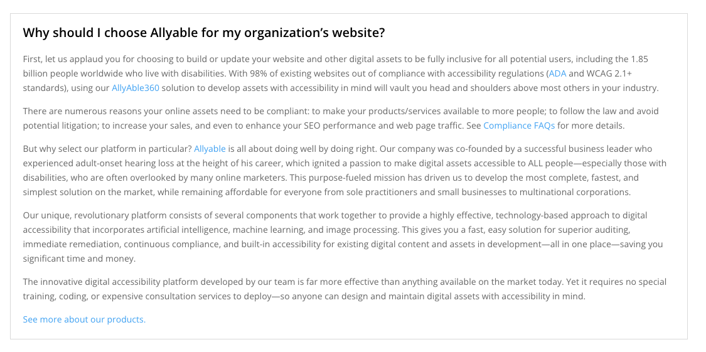)

Figure :Why should I choose Allyable? (Captured on October 21, 2021)

Allyable claims to be trusted by some big-name clients such as KPMG and Microsoft, but no evidence of this partnership appears to exist on the alleged clients’ web presence, or the company uses another widget (i.e., Olo).

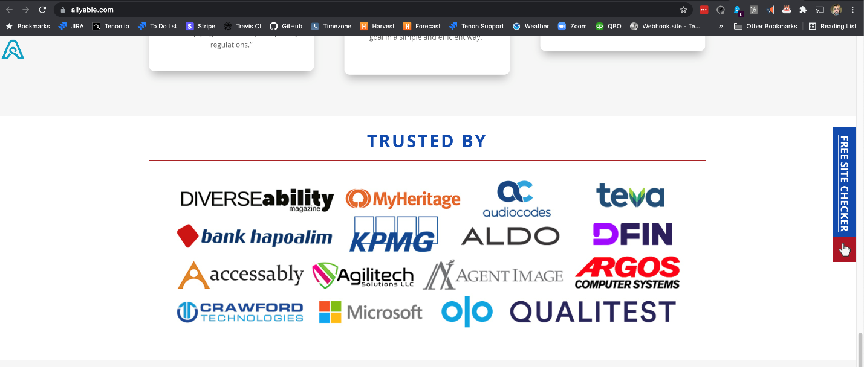

Figure : Trusted By (Captured on October 21, 2021)

## Evidence from Twitter

<https://twitter.com/allyable>

On their Twitter profile, allyable claims it is, “[t]he fastest way to reach your digital accessibility goals.” (<https://twitter.com/allyable>), which is an easy boast when you also claim that you are the “only digital accessibility provider that gives an end-to-end solution”:

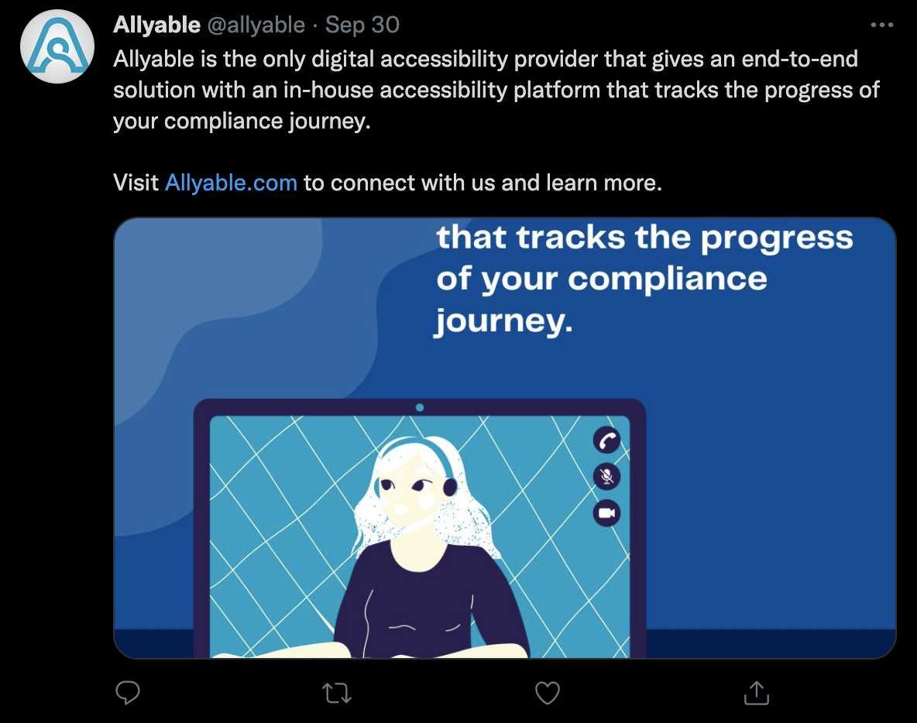

Figure : Allyable is the only digital accessibility provider (Captured on October 21, 2021)  
<https://twitter.com/allyable/status/1443592062528413704>

The company promises the “easiest and fastest solution to make your digital assets ADA compliant”:

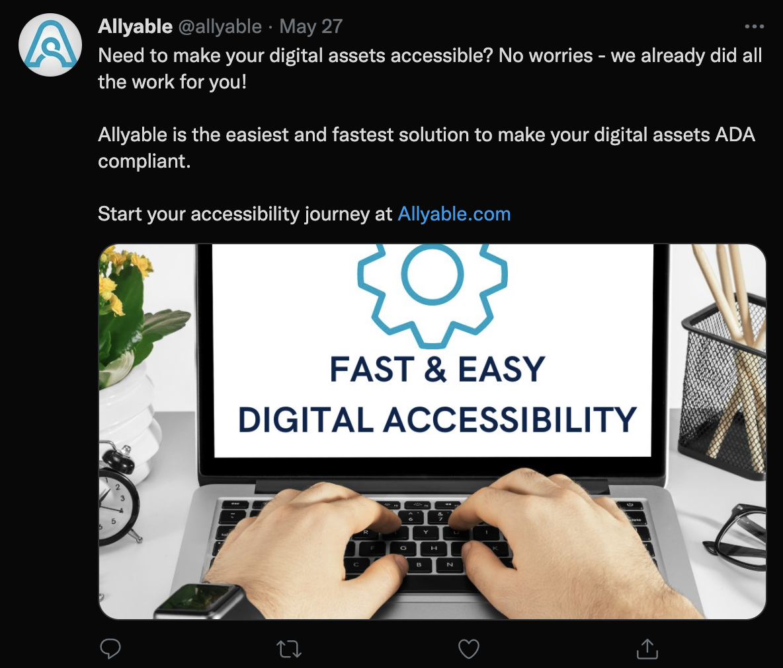

Figure : Fast & Easy (Captured on October 21, 2021)   
<https://twitter.com/allyable/status/1397916050075701250?s=20>

In this tweet, Allyable touts that its solution is “truly accessible” and “beyond just a toolbar”:

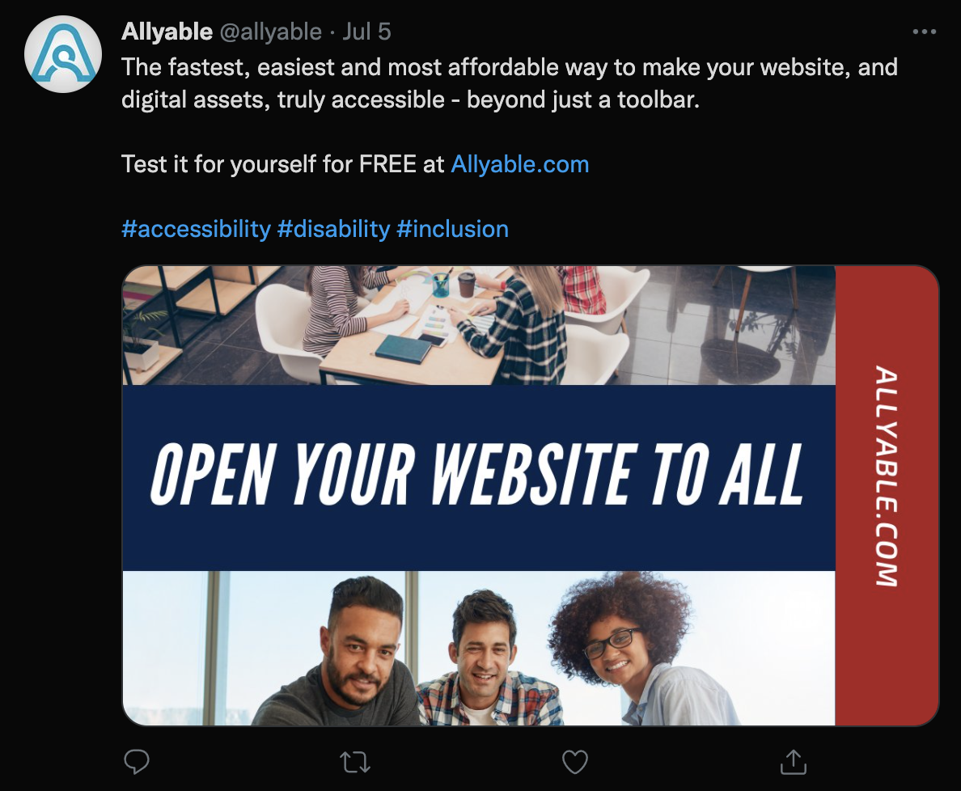

Figure : Open Your Website to All (Captured October 21, 2021)  
<https://twitter.com/allyable/status/1412090355277877259?s=20>

Finally, the company promises that its AllyFix™ product uses “advanced AI…to consistently correct most identified eros [sic] automatically”:

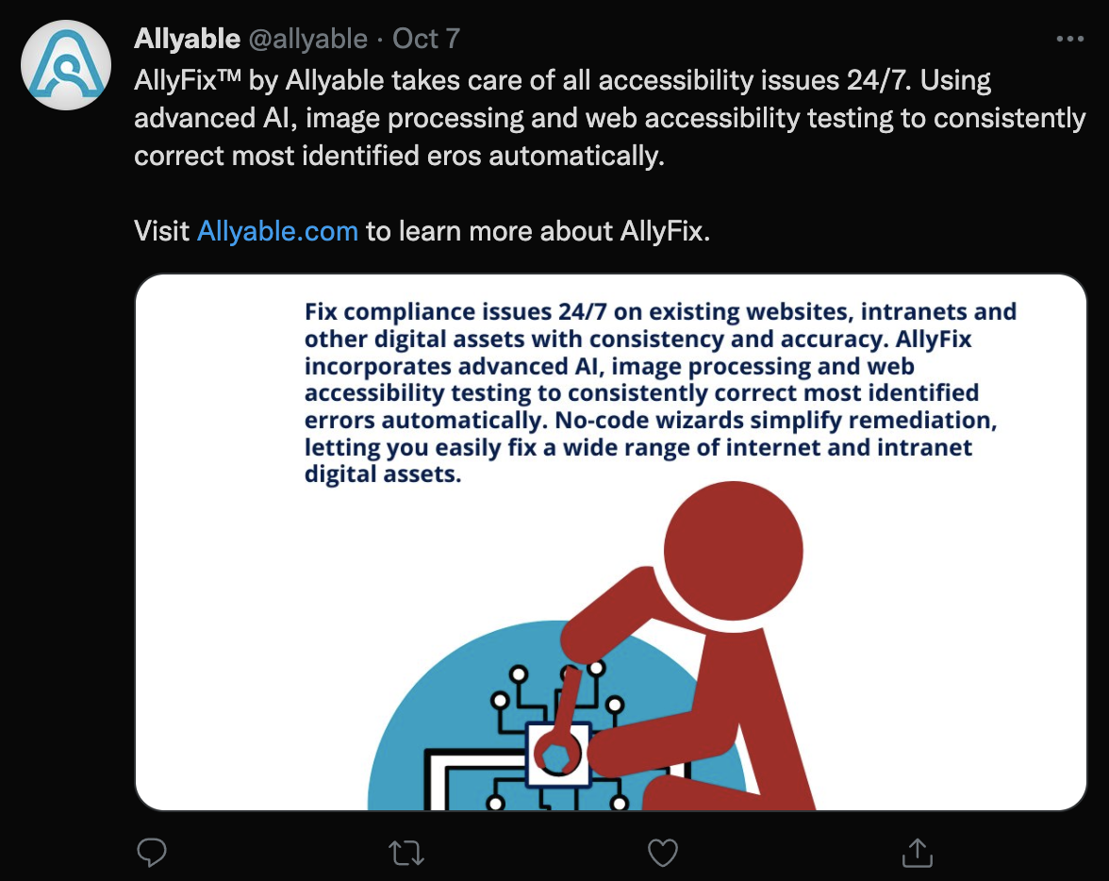

Figure : AllyFix (Captured October 21, 2021)  
<https://twitter.com/allyable/status/1446129081863471104?s=20>

# accessiBe

Address: 6 Hachilazon, RAMAT GAN, 5252270 Israel

Website: <http://accessibe.com>

“By using AI and automation, we can make thousands of websites accessible in the amount of time it used to make just one - and at a fraction of the cost. Our AI is taught to go beyond basic requirements and create an exceptional digital experience for people with disabilities.” (<https://accessibe.com/company>)

## Evidence from Website

The claims begin before the fold, so to speak, as one visits the accessiBe homepage, with claims of a “2-minute installation for 24/7 automatic accessibility”:

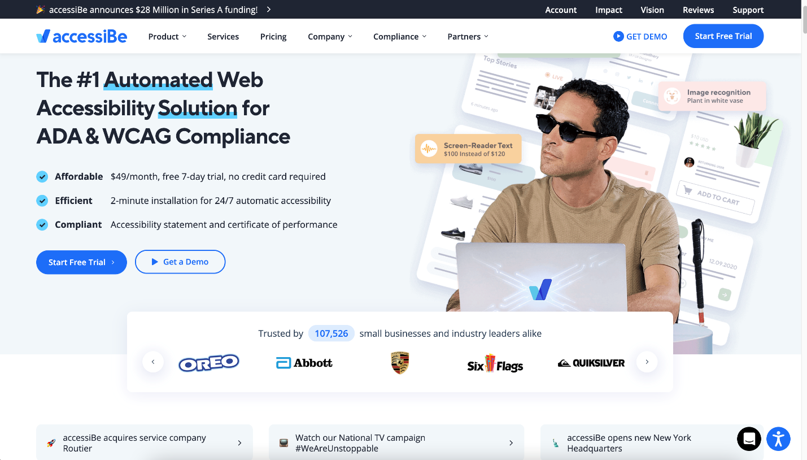

Figure : accessiBe Homepage (Captured on October 20, 2021)

The company’s website makes strong claims that their product will almost magically make any website accessible with only “a single line of JavaScript code”:

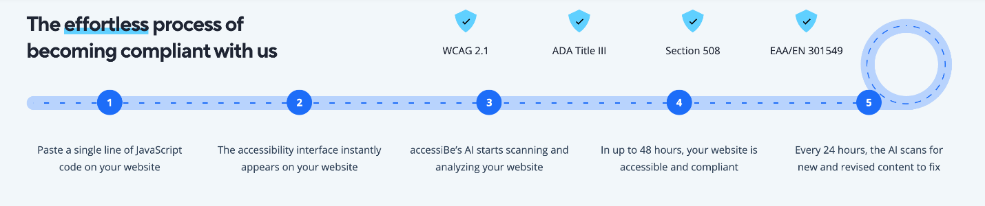

Figure : The effortless process (captured October 16, 2022)

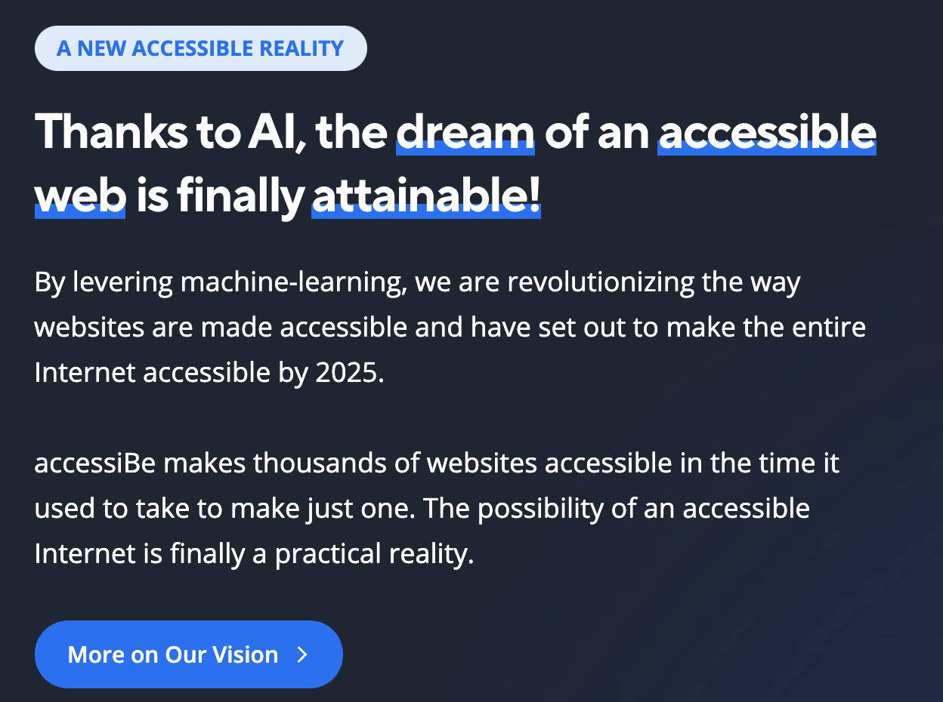

Figure : A New Accessible Reality (captured on October 16, 2021)

And (in our opinion), the most egregious claim is about using accessiBe can “stop any lawsuit in its tracks.” :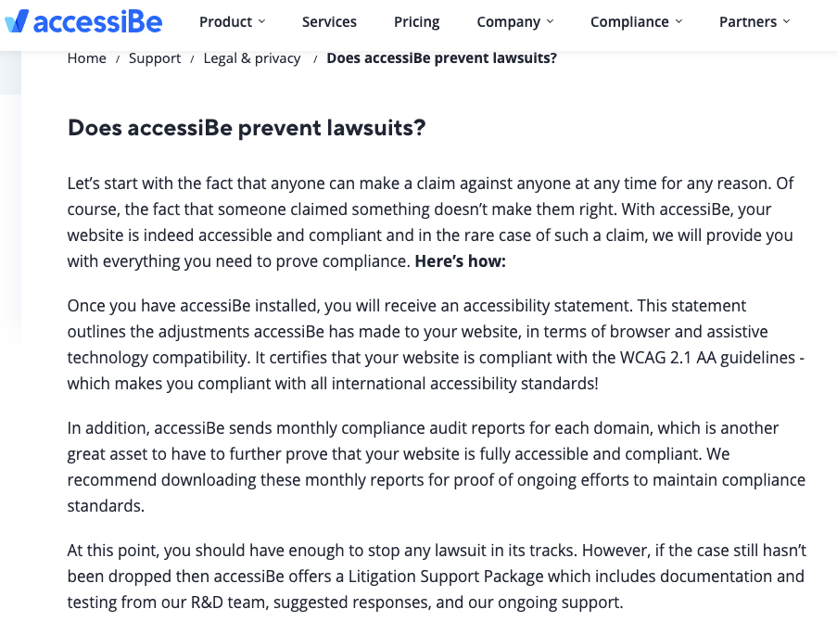

Figure : Does accessiBe prevent lawsuits? (Captured on October 18, 2021)

## Evidence from E-mail

The following is a marketing email from accessiBe received on March 23, 2021, wherein they claim to “remediate websites according to ADA and WCAG guidelines…within 48 hours.”![From: Elle - accessiBe <elle@accessibe.on.crisp.email>
Date: Tue, Mar 23, 2021 at 9:08 PM
Subject: Hey, I'm here if you have any questions
To: <tbosken@gmail.com>

Hey, I'm here if you have any questions

Hi Tema!

We remediate websites according to ADA and WCAG guidelines.

Here's what do[sic]:

accessiBe scans and analyzes your website using AI technologies. Then, it appplies all required adjustments to become ADA and WCAG 2.1 compliant. This process takes up to 48 hours from installation.

The process of becoming compliant using our solution is very simple:

1. Install our single line of JS code.
2. Your website instantly displays our accessiblity interface.
3. Our AI starts scanning and analyzing your website.
4. In 48 hours, our AI is finished, and your webiste is compliant.
5. Our AI re-scans for new and revised content to process every 24 hours.

The accessibility interface solves 30% of the ADA and WCAG 2.1 requirements immediately.  This includes mostly UI and design features such as sizing, colors, and spacing.

The remaining 70% are solved within 48 hours, by our AI that runs in the background and adjusts your website, to make it operaable using a screen reader (for blind people) and the Keyboard[sic] (for the motor impaired).

The AI process includes several solutions: ALT (alternate text) attribute creation for images using image recognition and OCR technologies, form label creation and handling link/button icons using a contextual understanding technology, as well as fixing popups, menus, dropdown, forms, and more.

Please note: accessiBe will not change a thing for the majority of users. It will only be activated when turned on via the interface (or a Screen-reader if the user is blind), as an overlay to your website, and only to the user's specific session.

Therefore, accessiBe won't affect your design, UI, or perfomance at all.

The entire process is automated. From remediation to becoming compliant, no manual work is being done.

--

Elle from accessiBe
](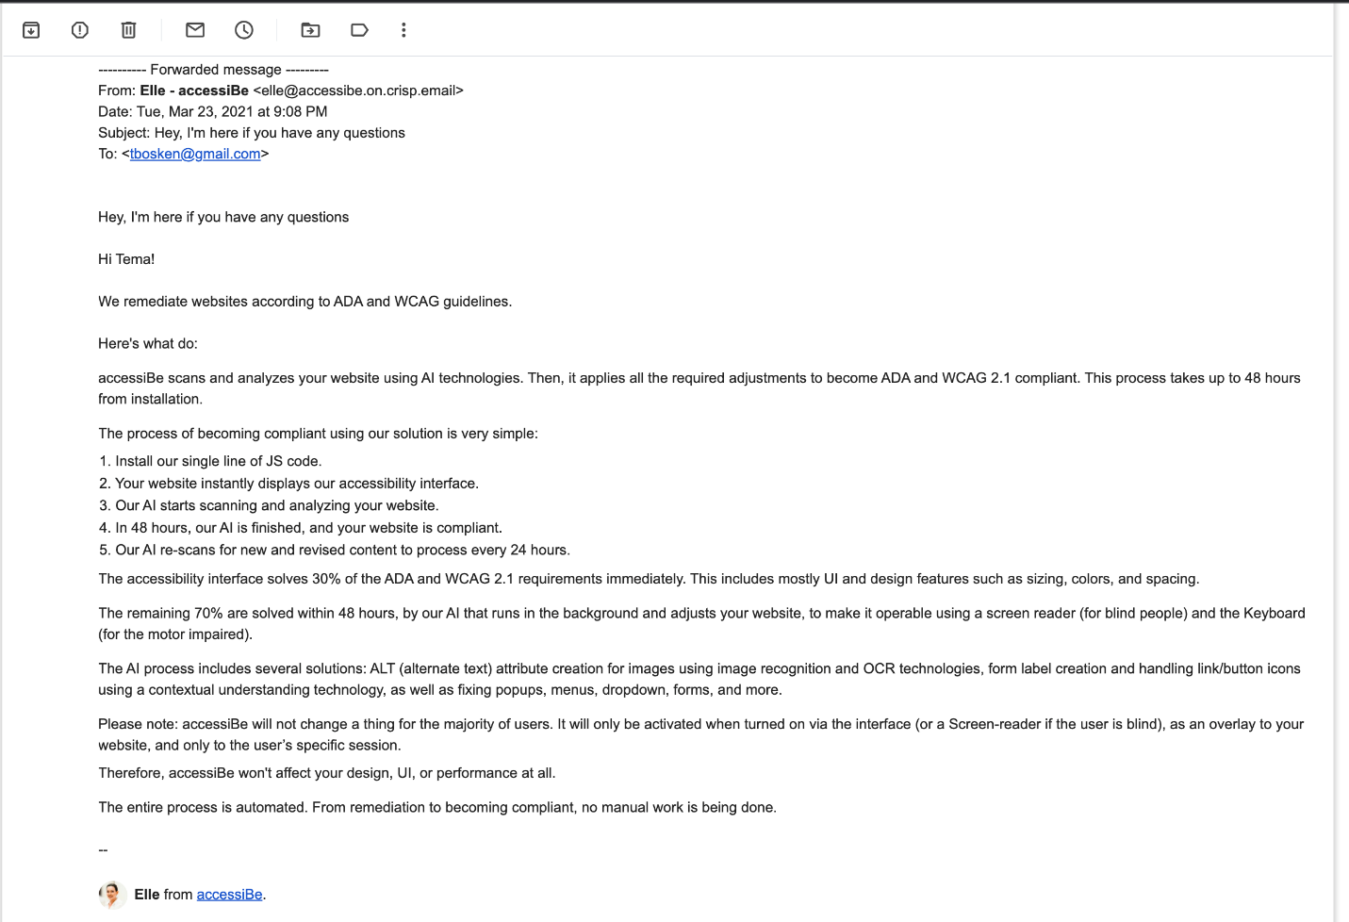)

Figure : Marketing email from accessiBe (received on March 23, 2021)

## Evidence from Twitter

<https://twitter.com/accessibe>

The company’s tweets often boast about how they can “make websites #ADA compliant”:

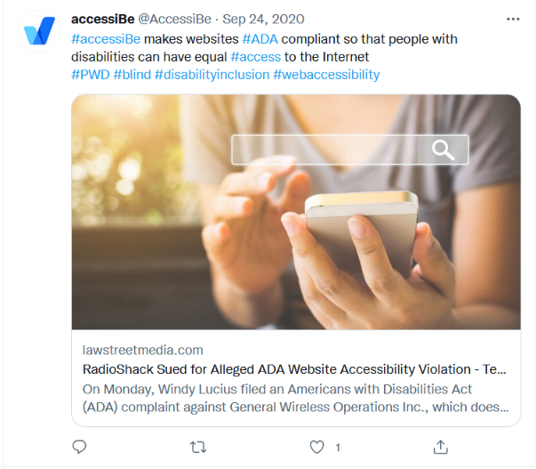

Figure : accessiBe makes websites ADA compliant (Captured on October 24, 2021) <https://twitter.com/AccessiBe/status/1309123843995377673>

## Evidence from Facebook

<https://www.facebook.com/accessibe>

The company also actively uses Facebook as a marketing tool, often touting its ability to allow websites to “meet ADA compliance without spending an arm and a leg”:

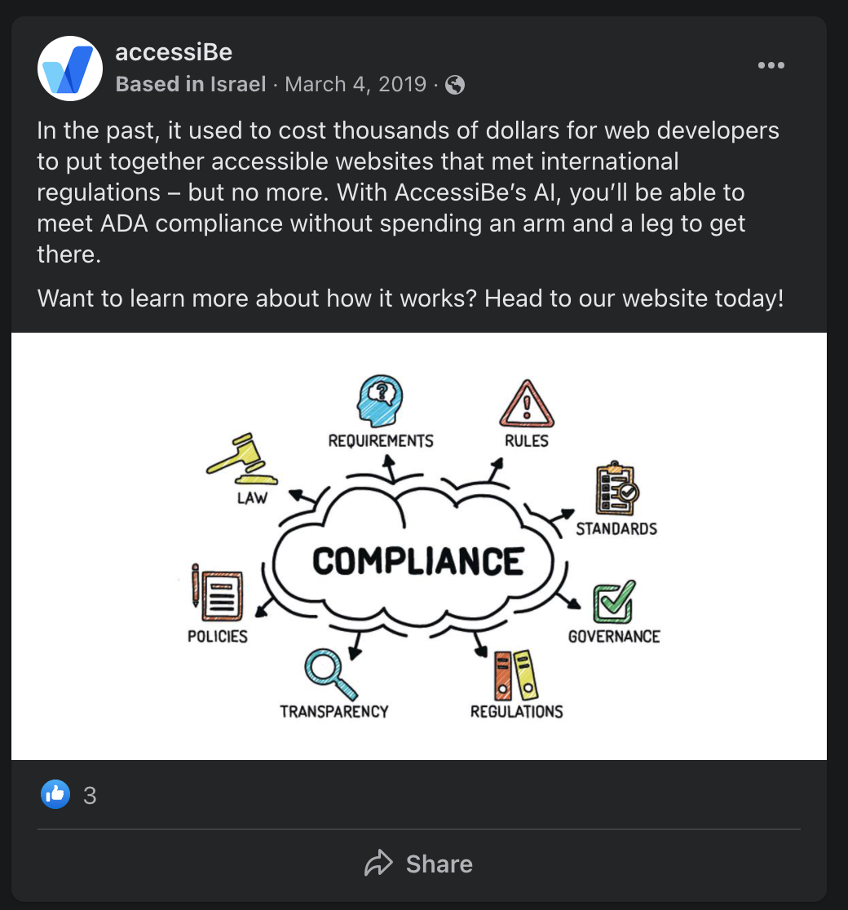

Figure : In the past… (<https://www.facebook.com/accessibe/posts/1156399274547046>)

The company also likes to publicize its how AI is “a better way” than manually fixing errors:

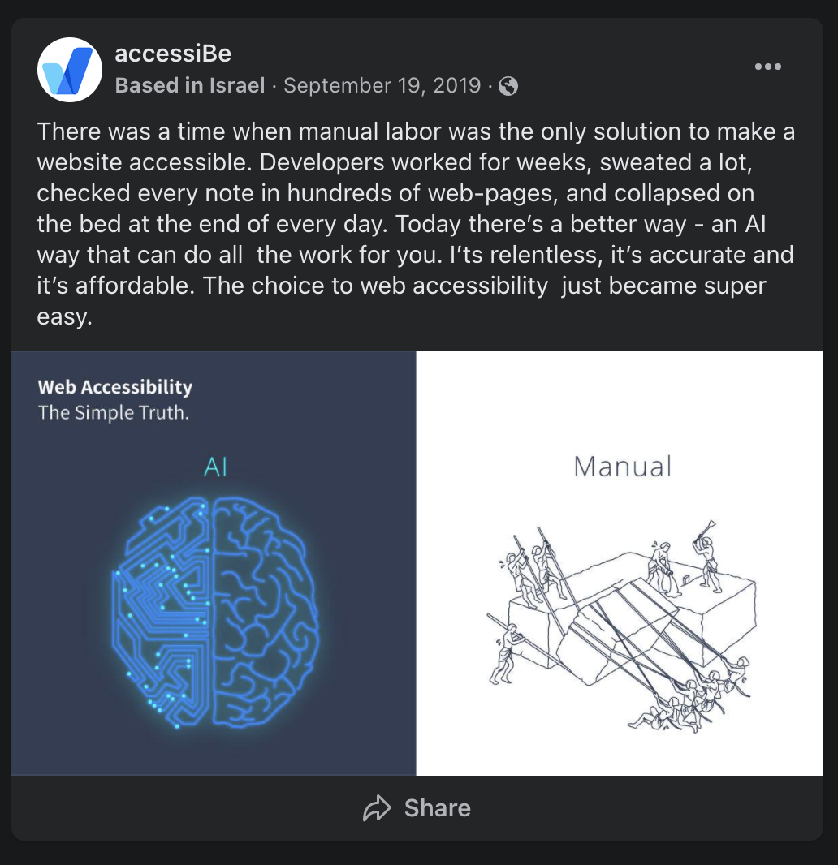

Figure : Manual Labor (<https://www.facebook.com/accessibe/photos/a.1070584513128523/1314238058763166>)

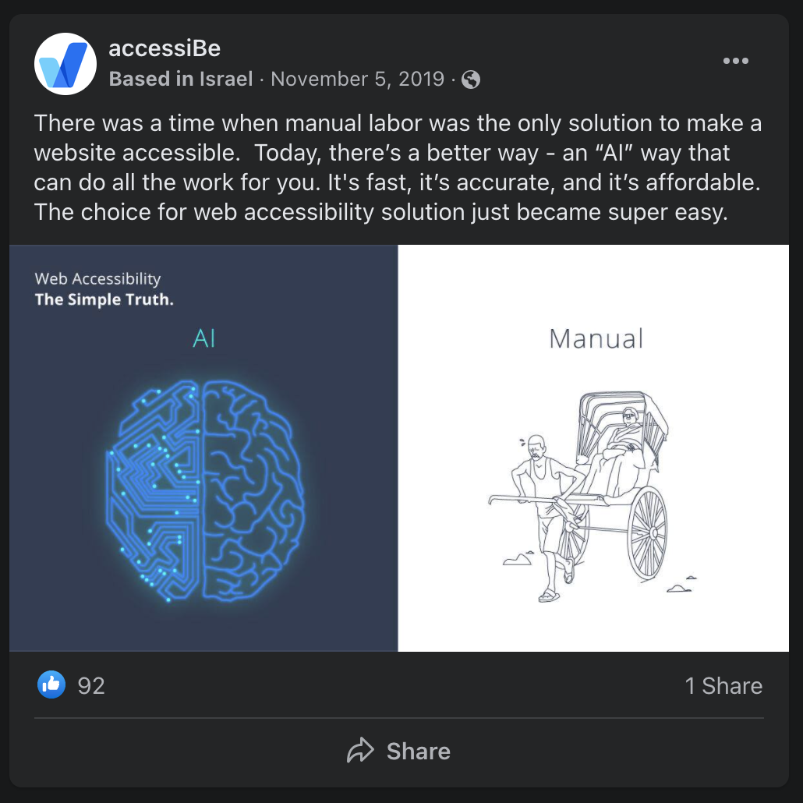

Figure : Manual Labor 2 (<https://www.facebook.com/accessibe/photos/a.1070584513128523/1364497460403892/?type=3>)

Facebook is also a place where they post videos declaring how their solution “solves web accessibility issues on every website”:

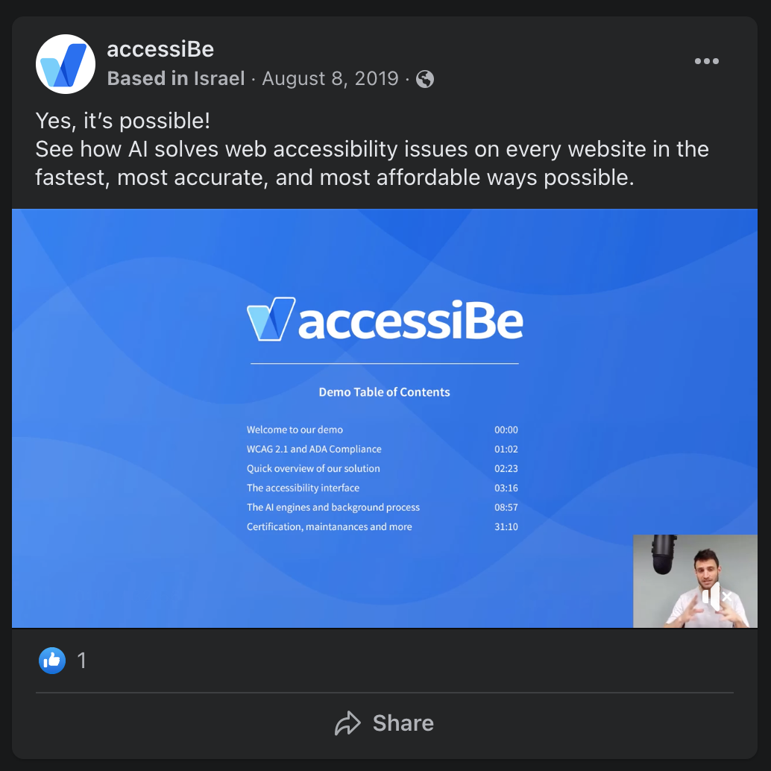

Figure : Yes, it’s possible! video (<https://fb.watch/8U59pVdrlc/>)

Finally, we find this example to be the most gauche, as it preys on a fear of people with disabilities:

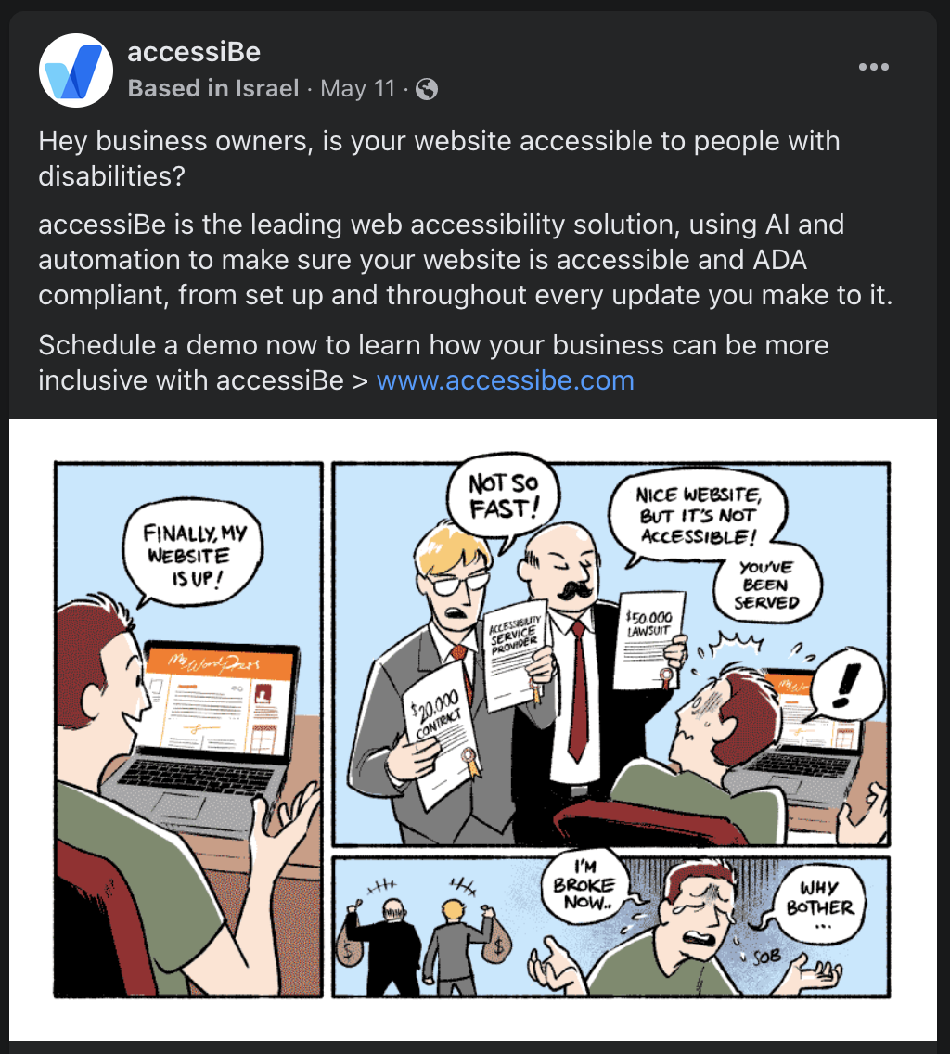

Figure : Hey Business Owners (<https://www.facebook.com/accessibe/posts/1948500805336885>)

## Evidence from LinkedIn

<https://www.linkedin.com/company/accessibe/>

In a comment on LinkedIn, CEO Shir Ekerling claimed that no company has ever been sued because of accessiBe. That may have been correct at the time of the post, but as we’ve shown, that’s not true anymore:

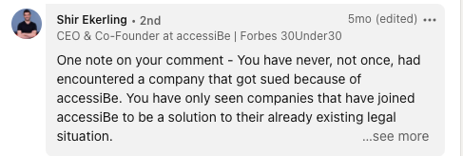

Figure : LinkedIn comment from Shir Ekerling

## Evidence from Google Ads (source: SpyFu.com)

accessiBe spends an estimated $16,531 on CPC ads per month.

40% of the accessiBe website traffic comes from CPC ads

The company’s advertising on Google suggests one can avoid being sued by using their product:

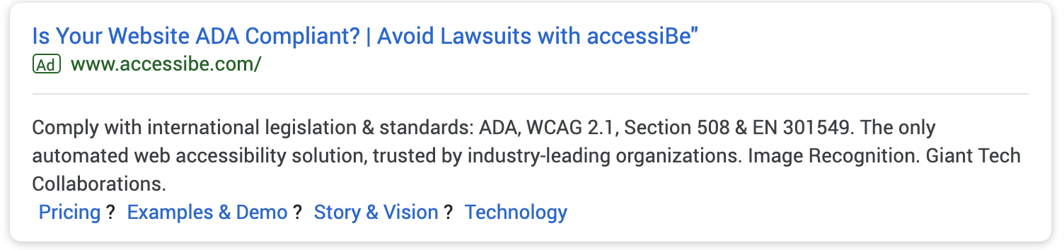

Figure : Is Your Website ADA Compliant Google Ad (captured January 1, 2020)

## Evidence of other anti-competitive behavior

When using an automated accessibility tool such as WAVE, accessiBe’s overlay blocks a proper scan of the site:

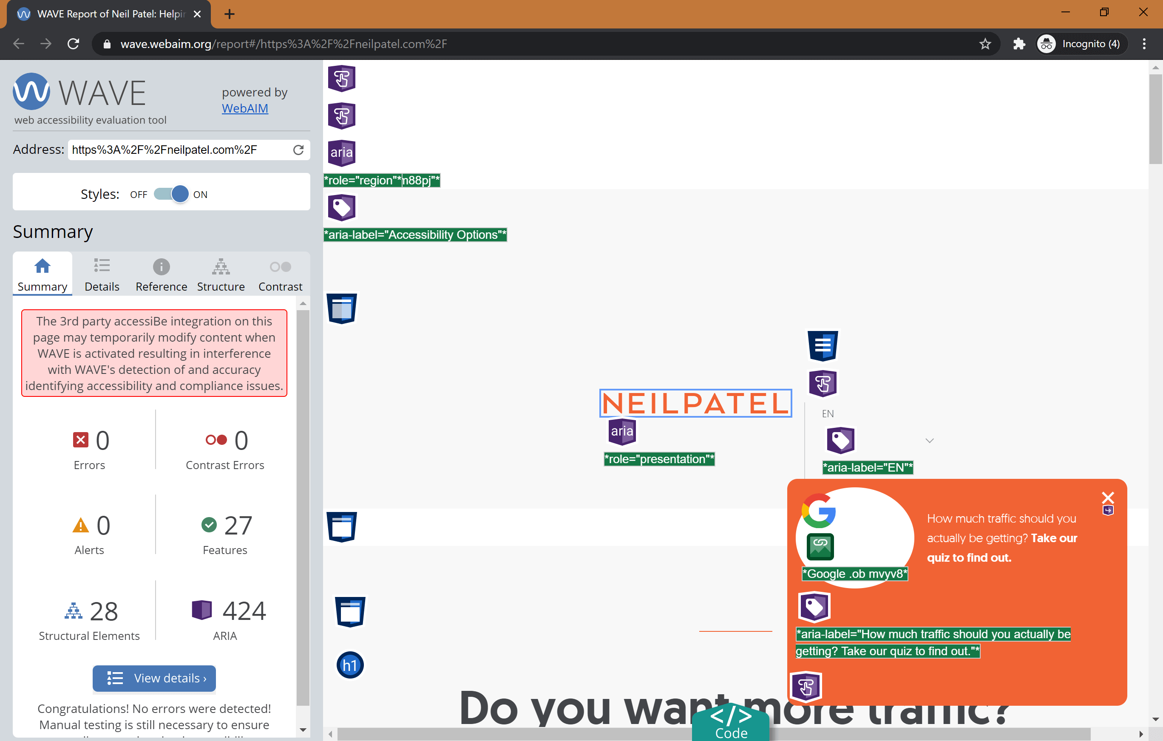

Figure : accessiBe Blocks Automated Scans

## Evidence that accessiBe’s solution does not live up to its promises

The captions that accessiBe automatically generates are poor even by auto-caption standards. The audio for the below was, “…collaborated with lead developers from the JAWS team…”:

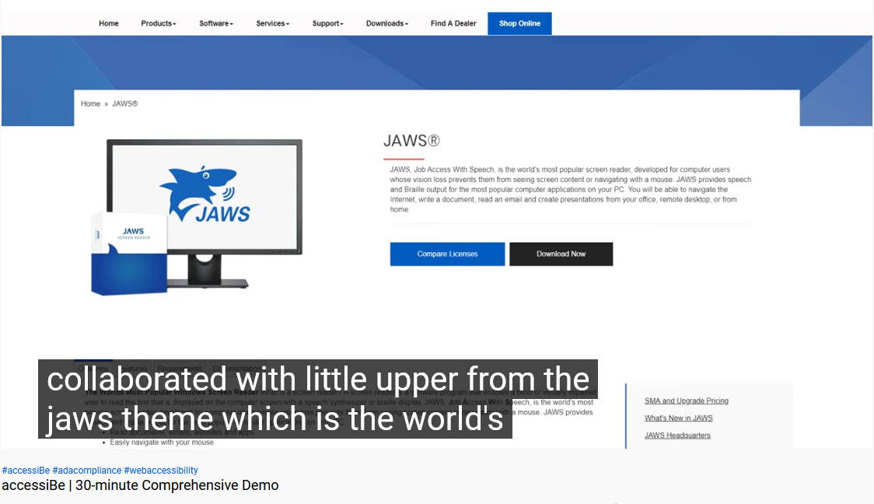

Figure : accessiBe's Auto Captions Fail

# Accessus.ai

Address: 102 West Pennsylvania Avenue Suite 401, Towson, MD 21204, United States

Website: https://accessus.ai/

“The Accessus.ai mission is to contribute towards making the entire internet completely accessible so that everyone, with or without disabilities, can enjoy the universe of content it has to offer.

In today's legal environment, ALL businesses are now challenged with meeting the current technical and compliance standards in addition to the potential threat of expensive litigation defense and settlement costs.

The Accessus.ai solution is designed with your complete technical and legal situation taken into consideration on a long-term basis.”

(<https://accessus.ai/about>)

## Evidence from Website

The company promises “Fully Automated WCAG 2.1 AA Compliance” in “less than 48 hours”:

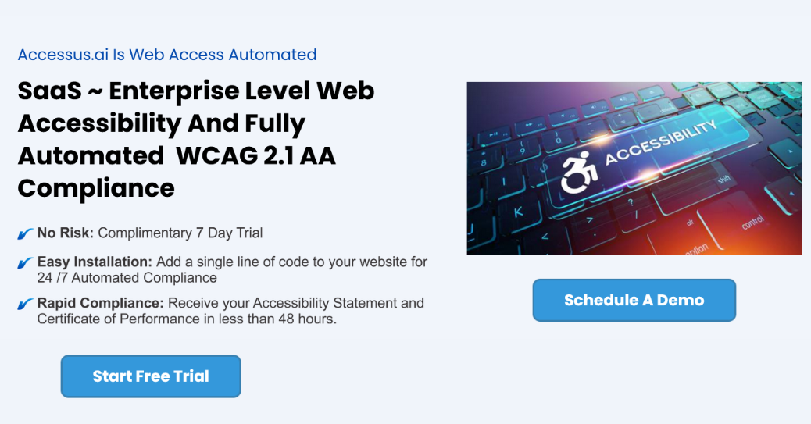

Figure : Accessus.ai is Web Access Automated (Captured October 27, 2021)

When one schedules a demo, they are told once again that compliance can be achieved in “less than 48 hours” using the company’s “Artificial Intelligence”:

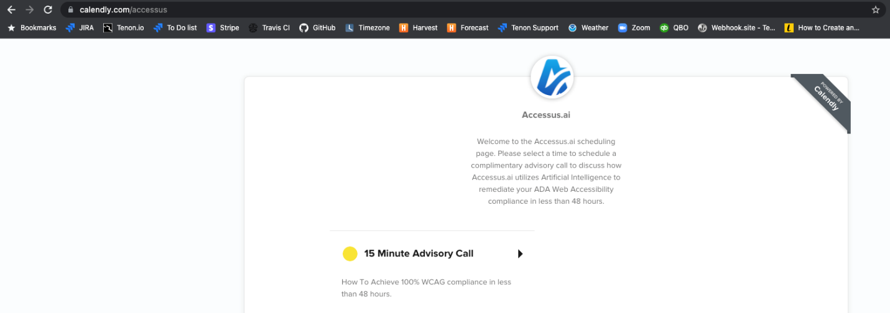

Figure : Schedule a 15 Minute Advisory Call

In addition to the familiar claims of “a single line of JavaScript code” to achieve “fully compliant and certified” status, Accessus.ai takes the low road by throwing some of its named clients (e.g., AudioEye, User1st, UserWay, WP Access) under the proverbial bus, claiming they cannot deliver the same scope of compliance (e.g., WCAG 2.1, ADA, s508) in a similar 48-hour time frame. They also claim that their solution has the “[i]ndustry highest success rate” while others only meet 5% to 50% of the requirements within 6 months without providing a source for this data:

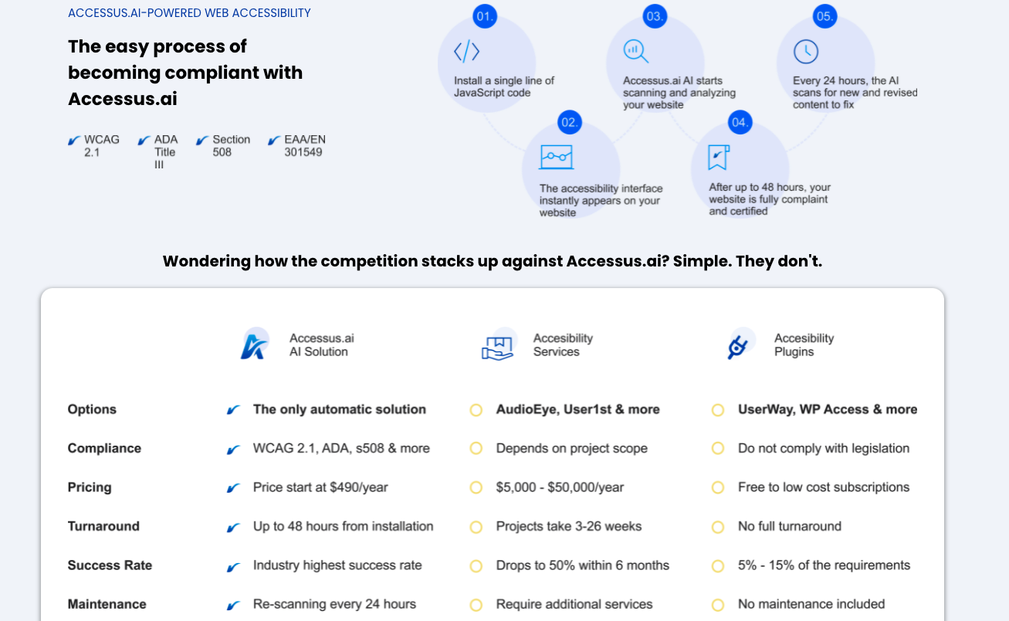

Figure : Accessus.ai-powered web accessibility

Much like other overlay companies, Accessus claims that its product can “[p]rotect and defend” against “costlylitigation[sic]”:

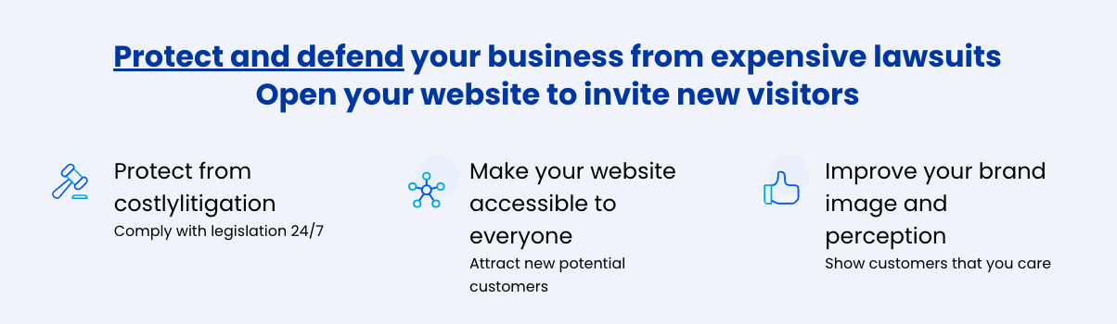

Figure : Protect and Defend

The company’s answer to how they provide protection from litigation makes the same bold and spurious claims as many of its competitors, including offering a worthless “Certificate of Performance”:

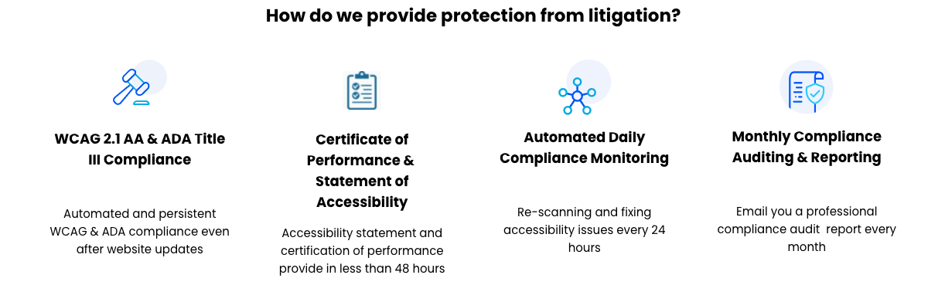

Figure : How Accessus provides protection from litigation

The company claims that their solution “provide[s] and maintain[s] 100% WCAG compliance standards.”

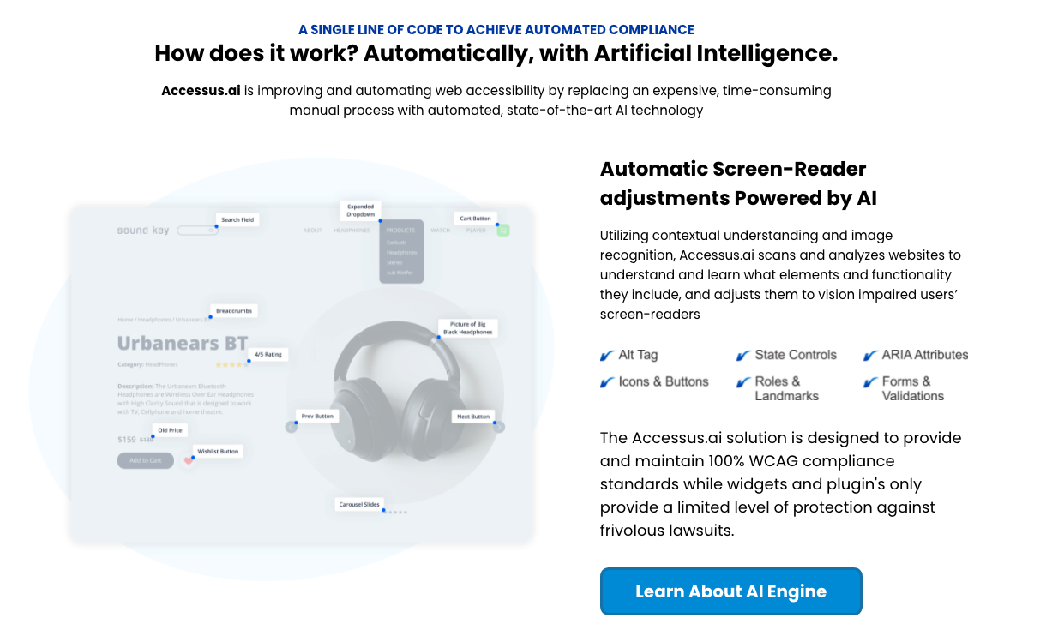

Figure : How does it work? (Captured October 27, 2021)

*Relatively unique among their peers, Accessus.ai also claims that their solution can offer CCPA and GDPR Compliance:*

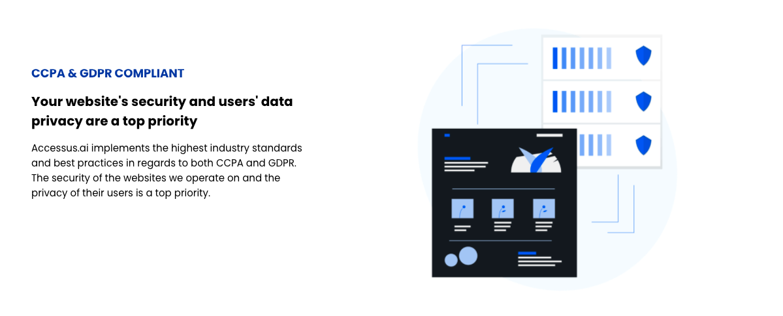

Figure : CCPA & GDPR Compliance

The company claims that their product will protect their customers from accessibility-related litigation and that the product covers **all**(emphasis mine) WCAG 2.1 AA (and some AAA) guidelines:

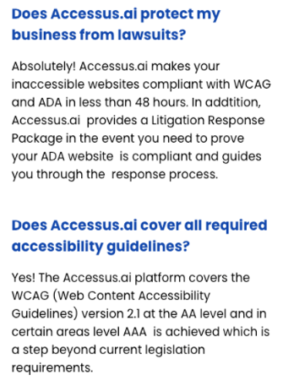

Figure : Accessus.ai FAQ (Captured October 20, 2021)

# ActiveIntent

Website: https://theactiveintent.com/

Active Intent makes your website voice activated on mobile and desktop.

Users can click on the generated microphone icon and start conversationally interacting with your website. (<https://theactiveintent.com/>)

## Evidence from Website

The company claims that voice activated websites, “ensure American with Disabilities Act compliance.”

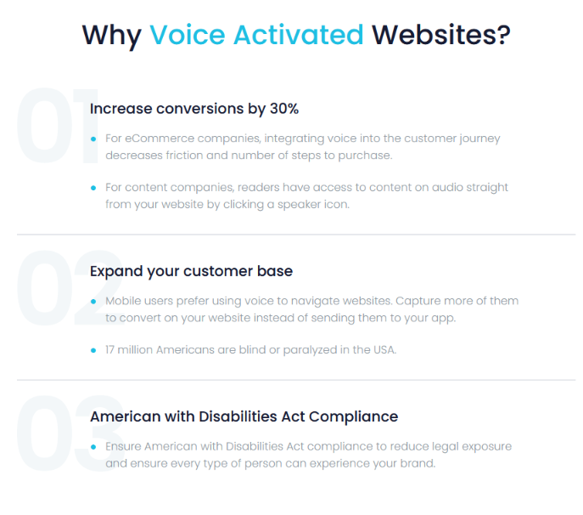

Figure : Why Voice Activated Websites (captured on October 27, 2021)

# AudioEye

Address: 5210 E Williams Circle, Suite 750, Tucson, Arizona 85711, US

Website: https://www.audioeye.com/

“AudioEye’s industry-defining digital accessibility platform delivers website compliance efficiently and affordably for organizations of all sizes. Our platform leverages a decade of investment in advanced technology supported and informed by our team of dedicated IAAP-certified professionals to help deliver improved access to the web.” (<https://www.audioeye.com/about-us>)

## Evidence from Website

AudioEye claims several high- profile customers, at least one of whom, WebMD does not reciprocate the claim on their respective websites:

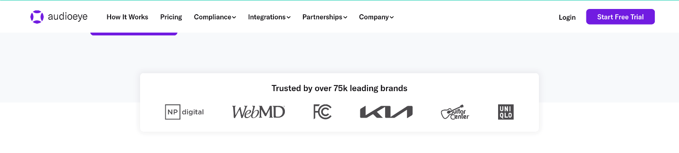

Figure : Trusted by over 75k leading brands

## Evidence from Twitter

<https://twitter.com/audioeyeinc>

The company claims its product will, “get you compliant on day one.”

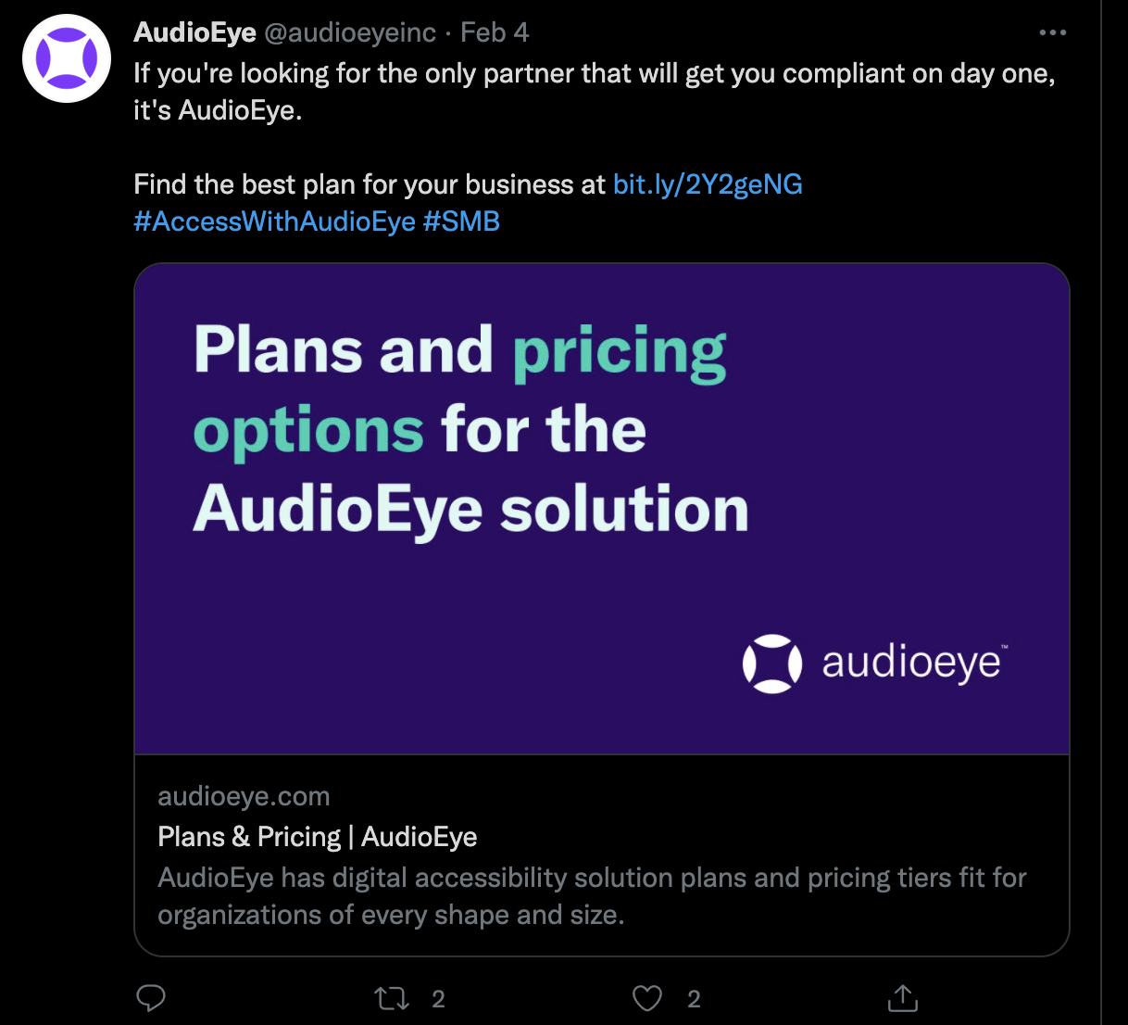

*Figure 33: Find the best plan (Captured October 21, 2021)*[*https://twitter.com/audioeyeinc/status/1357340661041623044?s=20*](https://twitter.com/audioeyeinc/status/1357340661041623044?s=20)

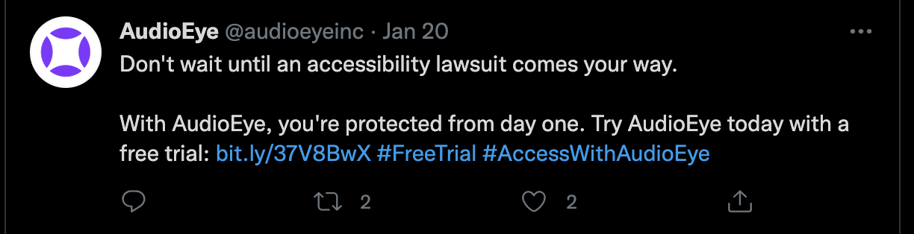

Figure : Protected from Day One (Captured October 21, 2021)  
<https://twitter.com/audioeyeinc/status/1351955182326841346>

## Evidence from Google Ads (source: SpyFu.com)

AudioEye spends an estimated $24,786 on CPC ads per month.

62% of the AudioEye website traffic comes from CPC ads.

The company Google Ads make promises of compliance with accessibility laws and standards “on Day 1.”

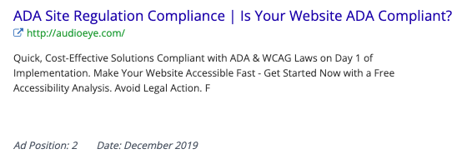

Figure : ADA Site Regulation Compliance (Captured by Spyfu in December 2019)

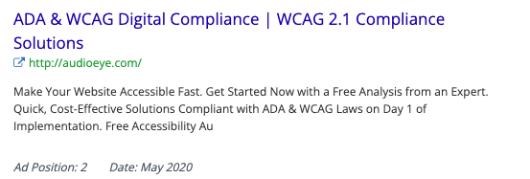

Figure : ADA & WCAG Digital Compliance

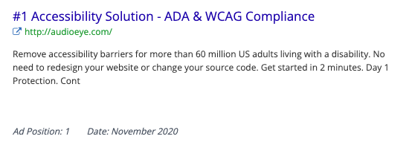

Figure : ADA & WCAG Compliance

Some of the company’s ads use the scare tactic of an impending lawsuit and suggest one not “wait to be served”:

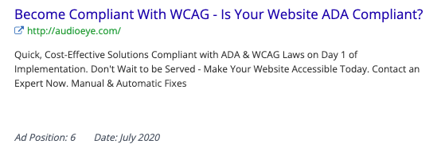

Figure : Become Compliant with WCAG

AudioEye also offers “Certified ADA Compliance” even though such a certification does not exist:

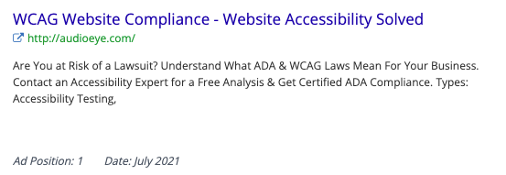

Figure : Website Accessibility Solved

Finally, like many of its competitors, the company claims to be the only solution out there:

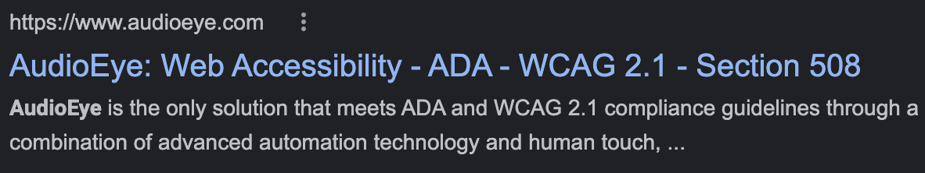

Figure : AudioEye is the only solution

# EqualWeb

Address: 447 Broadway, 2nd FL #239 New York, NY 10013

Website: <https://www.equalweb.com/>

“EqualWeb is a development company that specializes in accessibility and advanced internet applications.

With more than two decades of experience, working closely with the blind and disabled, we have gained the confidence and support of many global customers. Our inspired and highly-experienced team of IT, accessibility experts, designers, programmers, and marketing experts are committed to one common goal - effectively offering an accessibility solution for your websites via an extremely simple and cost-effective process.” (<http://www.equalweb.com>)

## Evidence from Website

The company claims its widget “provides full ADA and WCAG 2.1 compliance” with, “no code changes required.”

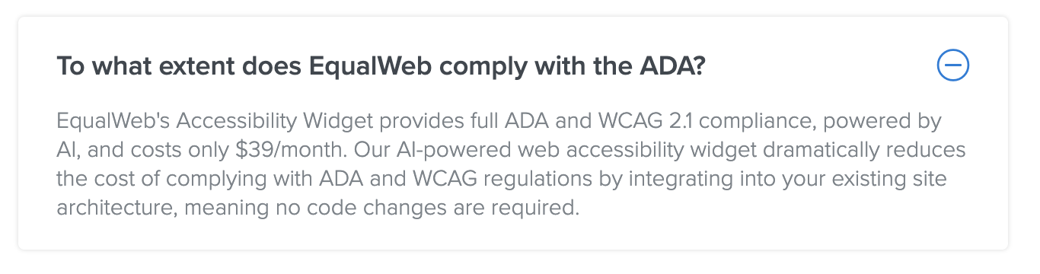

Figure : To what extent does EqualWeb comply with the ADA? (Captured October 24, 2021)

EqualWeb claims its solution is “over 100 million web pages” and that they provide their clients with “1,00,000$ [sic] in digital accessibility warranty”: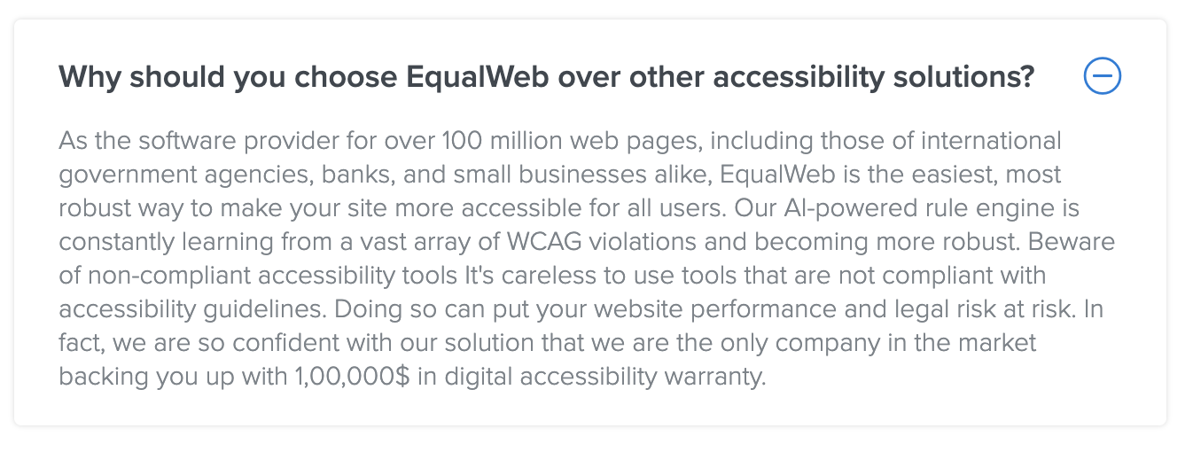

Figure : Why should you choose EqualWeb…? (Captured October 24, 2021)

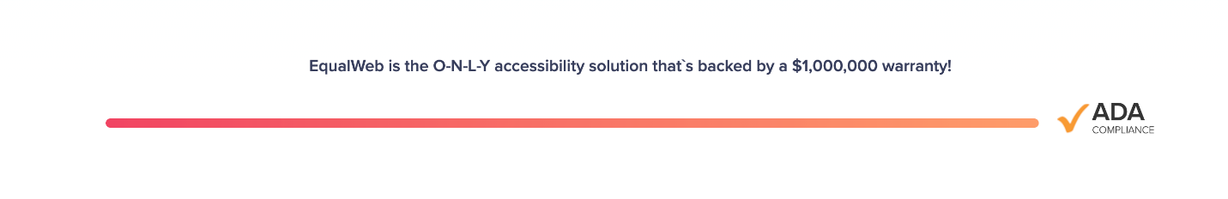

Figure : $1,000,000 warranty (Captured October 24, 2021)

Instead of providing names of its marquee clients, the company claims that their solution is installed on over 100 million web pages in a bogus attempt to conflate pages with clients and confuse prospective customers about its market penetration:

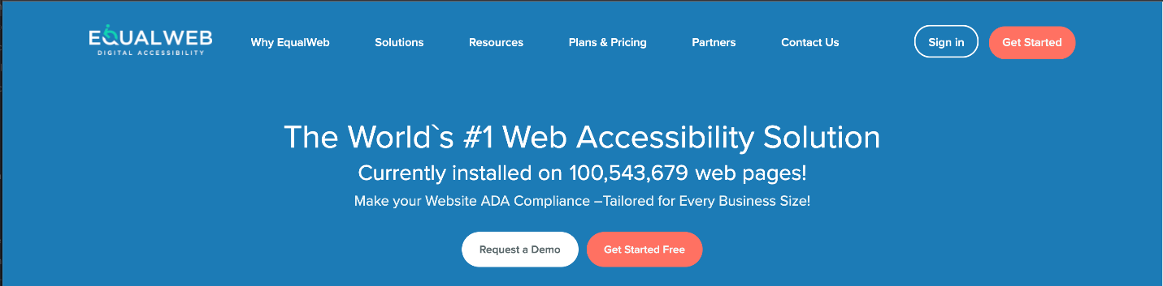

Figure : Currently installed on 100,543,679 web pages (Captured on October 24, 2021)

EqualWeb maintains that, aside from it’s supposed unique $1,000,000 warranty, it also uniquely provides compliance with accessibility standards while “all others” only promise a portion of that compliance goal and that “all others” do not offer on-going maintenance:

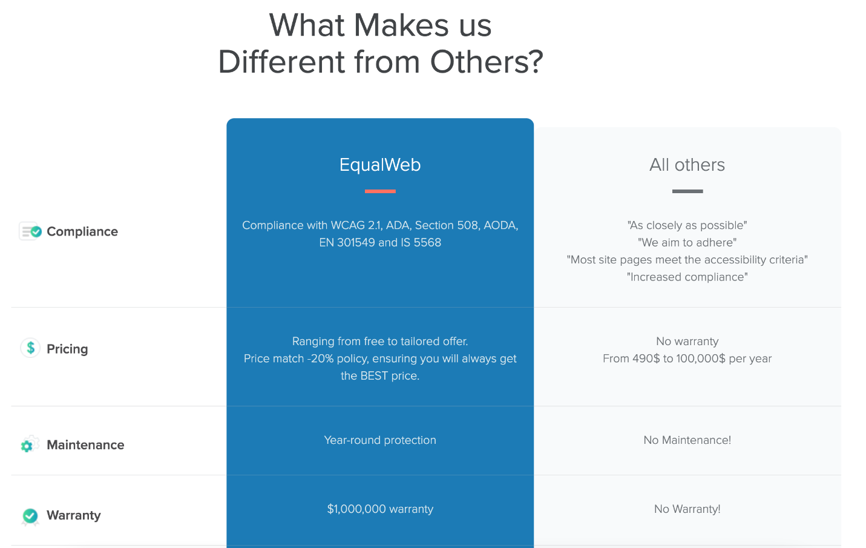

Figure : What Makes EqualWeb Different (Captured on October 24, 2021)

## 

## Evidence from Twitter

Out of the proverbial gate, EqualWeb touts its solution as “instantly applicable” that meets “International Accessibility Standards”:

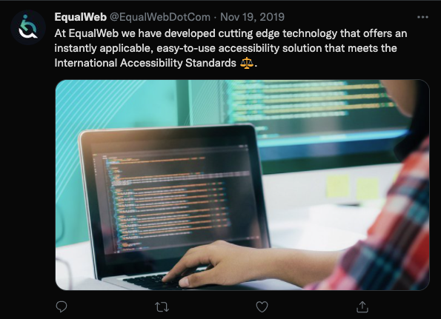

Figure : Instantly Applicable  
<https://twitter.com/EqualWebDotCom/status/1196812164964724737>

EqualWeb claims that its widget will “automatically adjust” a website to fix keyboard navigation issues:

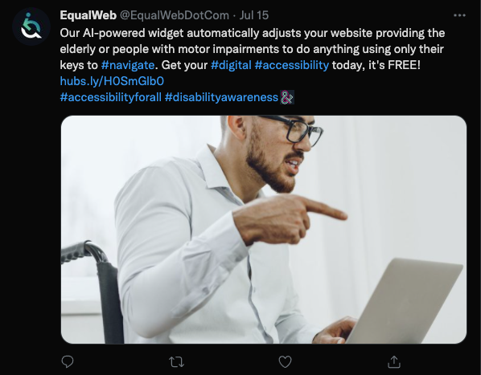

Figure : Only Their Keys to #navigate

In this tweet, the company makes the claim that 20 years of experience specializing in web accessibility has allowed them to offer a “simple and cost-effective solution,” suggesting that they’ve been offering an overlay widget for that length of time:

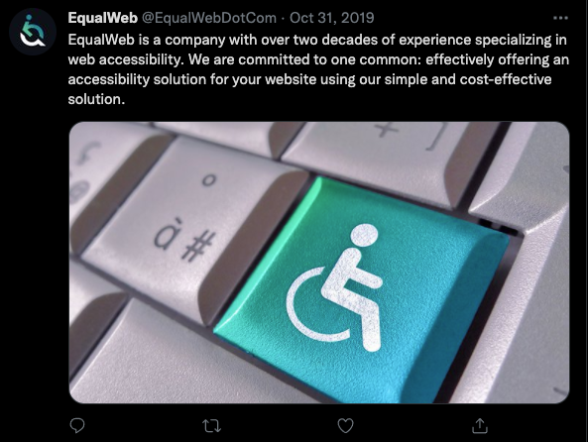

Figure : Two Decades of Experience  
<https://twitter.com/EqualWebDotCom/status/1189888468534616064>

By way of promising increased traffic to one’s website, EqualWeb claims to offer “100% ADA WCAG 2.1 AA” compliance. Curiously, they do not give a link in this tweet but instruct the user to go all the way back to the bio on their Twitter account to access a link:

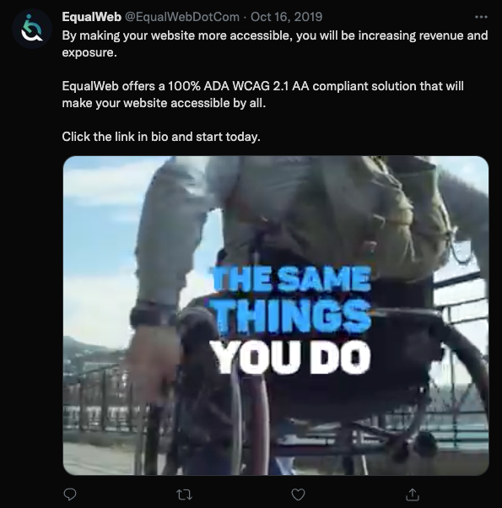

Figure : Increase Revenue and Exposure  
<https://twitter.com/EqualWebDotCom/status/1184555355885522951>

The company claims that its “AI-powered accessibility solution” will assist in gaining brand recognition:

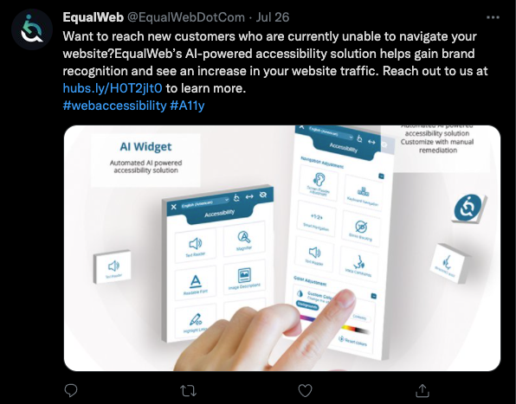

Figure : Brand Recognition  
<https://twitter.com/EqualWebDotCom/status/1419618973860171781>

In this tweet, the company talks up its “premium #accessibility solution” that offers a “fully compliant” website as way to bring up its alleged $1 million warranty:

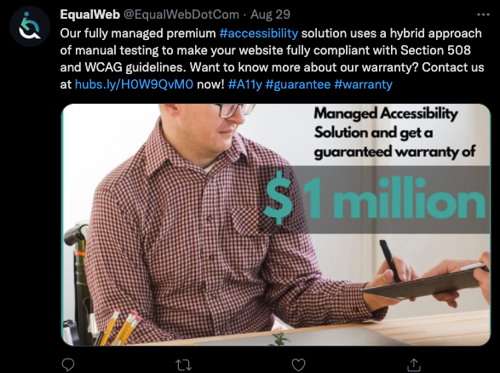

Figure : Hybrid Approach  
<https://twitter.com/EqualWebDotCom/status/1431943453169045504>

## Evidence from Facebook

<https://www.facebook.com/EqualWebDotCom>

In the About section of their Facebook page, EqualWeb claims it provides “digital accessibility solutions making websites 100% compliant”:

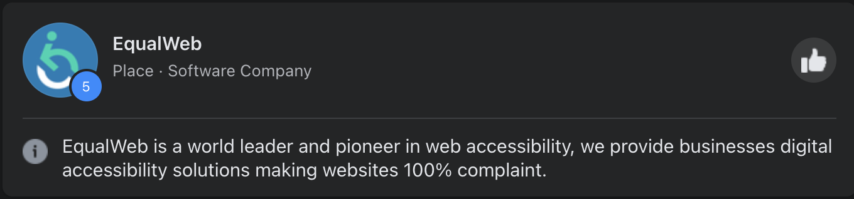

Figure : EqualWeb Facebook (Captured on October 27, 2021)

## Evidence from Google Ads (source: SpyFu.com)

EqualWeb spends an estimated $4239 on CPC ads per month.

22% of the EqualWeb website traffic comes from CPC ads

As with many of their peers, EqualWeb uses scare tactics in their marketing by saying that their solution will help their customers “avoid lawsuits”:

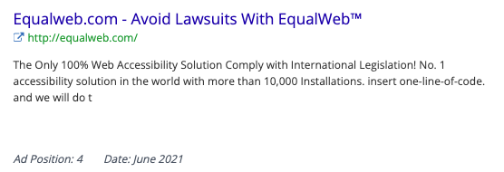

Figure : Avoid Lawsuits with EqualWeb™

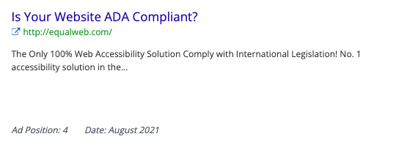

Figure 53: Is Your Website ADA Compliant?

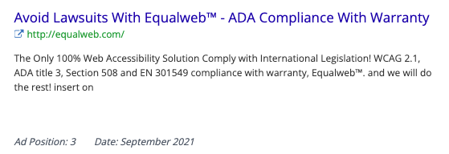

Figure : ADA Compliance With Warranty

The company also uses Google Ads to claim it is the “Only 100% Web Accessibility Solution” with “more than 10,000 installations”:

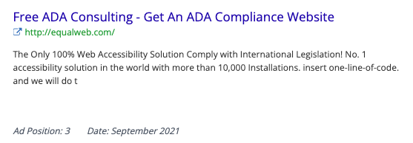

Figure : Free ADA Consulting

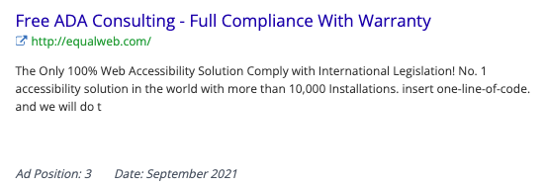

Figure : Full Compliance With Warranty

# Max Access (by Online ADA)

Address: 207 E 5th Ave. Ste 240, Eugene, OR 97401

Website: <https://maxaccess.io/>

“Since 2014 Online ADA has been the leading innovator in digital accessibility, providing the highest quality tools for developers to make the internet accessible to everyone.

After years of constant innovation and development we bring you the most elegant and robust solution for digital accessibility.

– Max Access – “

(<https://maxaccess.io/story-vision/>)

## Evidence from Website

On their website, Max Access claims it can get a website “accessible in minutes and…will stay accessible even as you add new content”:

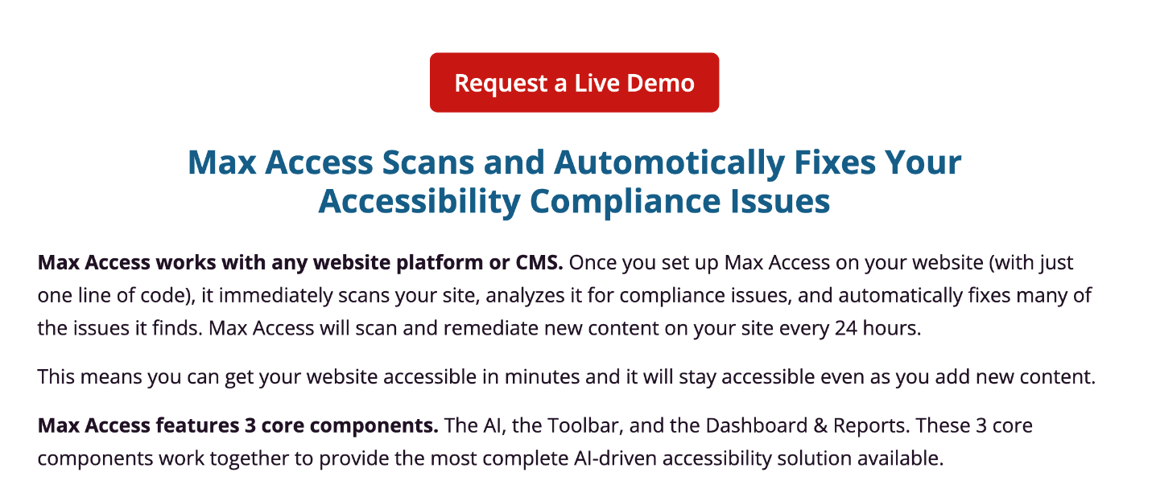

Figure : Max Access Scans and Automatically Fixes Your Accessibility Compliance Issues (Captured October 25, 2021)

The company’s website offers “automatic code fixes” and a “WCAG/AODA/ADA/Section 508 Compliant” solution:

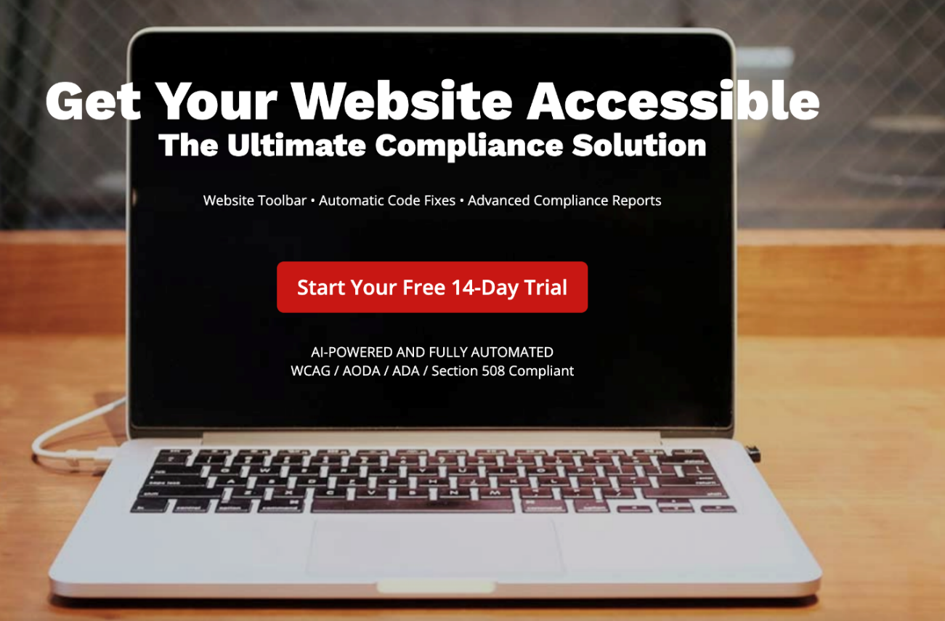

Figure : Get Your Website Accessible (Captured October 21, 2021)

The company’s website also engages in some scare tactics claiming that their product can help a client avoid lawsuits and “Maintain the Highest Level of Compliance 24/7”:

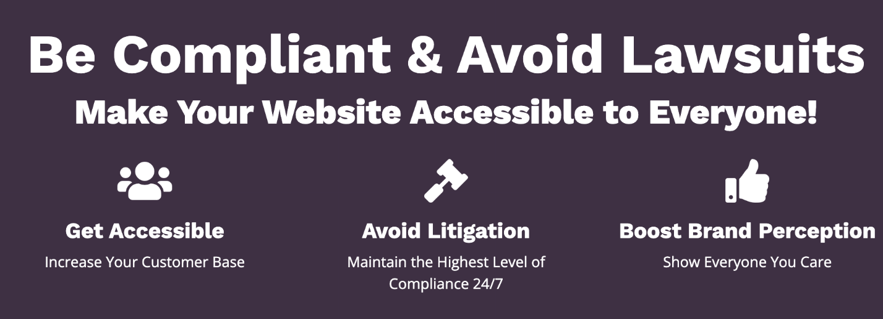

Figure : Be Compliant & Avoid Lawsuits (Captured on October 25, 2021)

Like most of their peers, MaxAccess promises that by installing “just 1 single line of code” your website can be made compliant and stay compliant due to the product re-scanning for new content every 24 hours: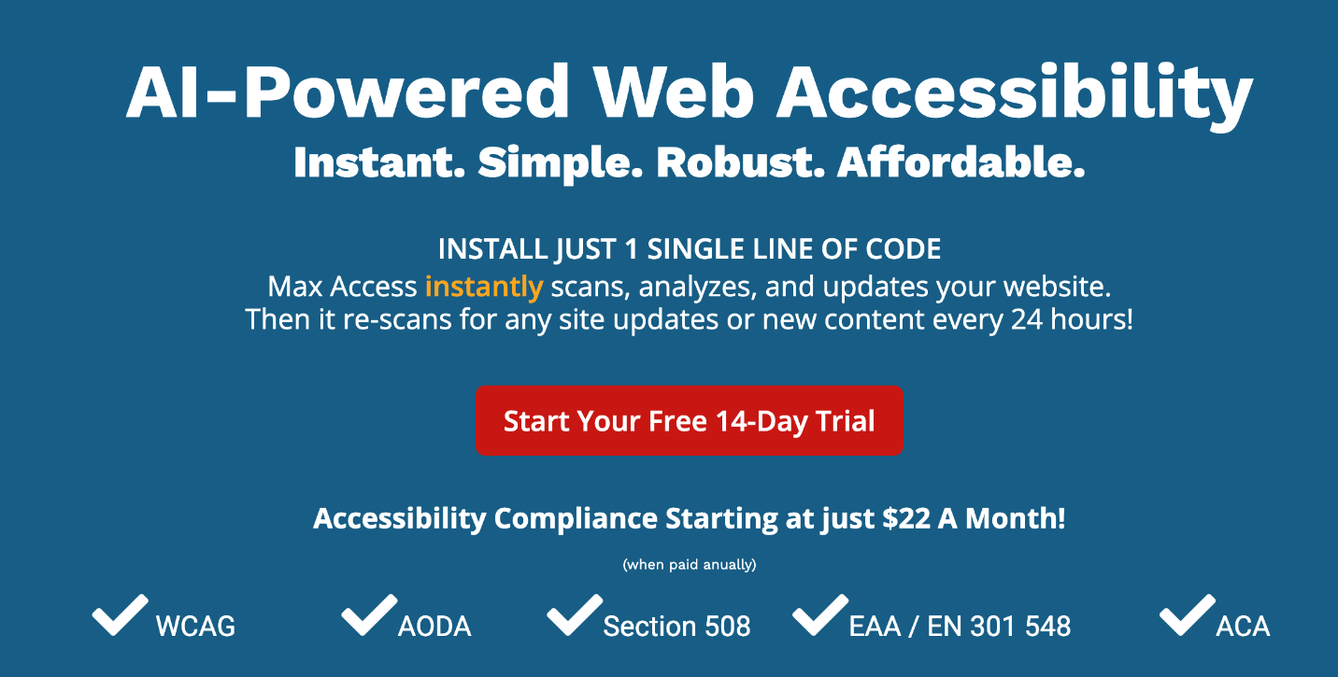

Figure : AI-Powered Web Accessibility

## 

## Evidence from Facebook

<https://www.facebook.com/digitalaccessibilityonline/>

The company claims that “Certification is the Only Accessibility Solution You’ll Ever Need,” although there is no recognized certification standard:

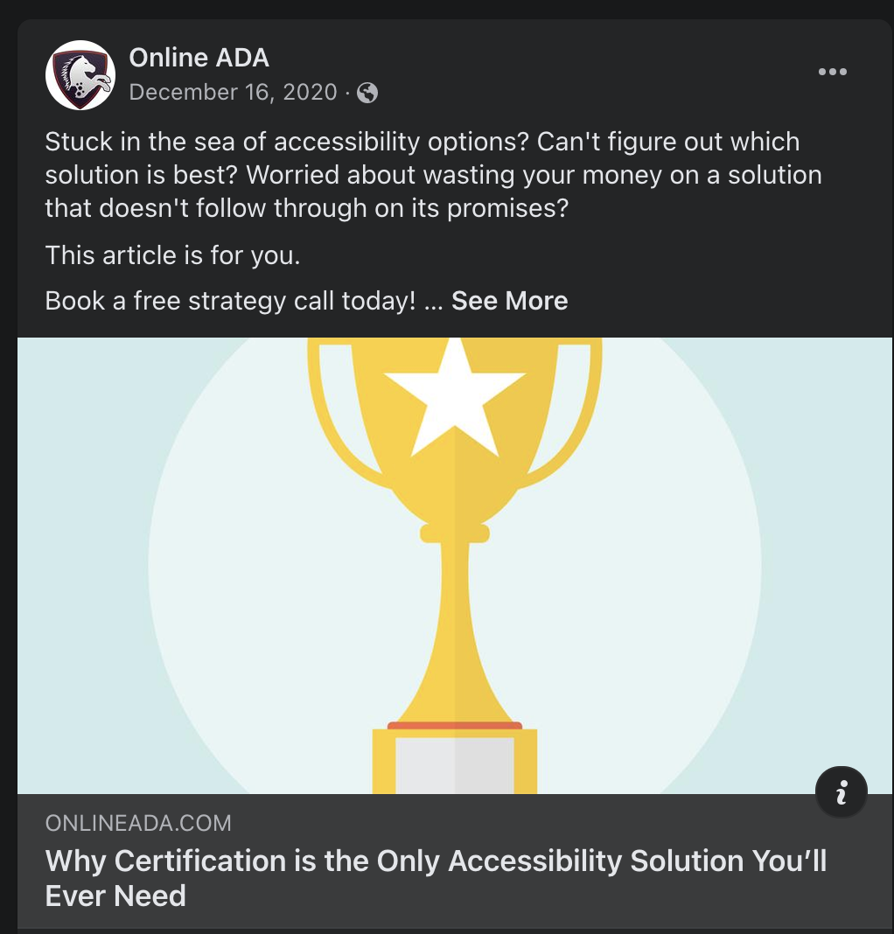

Figure : Why Certification is the Only Accessibility Solution You’ll Ever Need (Captured October 25, 2021)  
<https://www.facebook.com/digitalaccessibilityonline/posts/1974843319324858>

## Evidence from Google Ads (source: SpyFu.com)

OnlineADA/ MaxAccess spends an estimated $2736 on CPC ads per month.

86% of the MaxAccess.io website traffic comes from CPC ads

The company’s Google ads claim that their product offers, “Accessibility in 1 Click,” and can get your website, “Accessible in Minutes”:

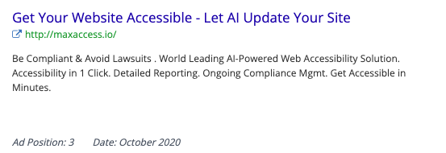

Figure : Get Your Website Accessible (Captured October 24, 2021)

MaxAccess uses the familiar lawsuit scare tactics in its ads:

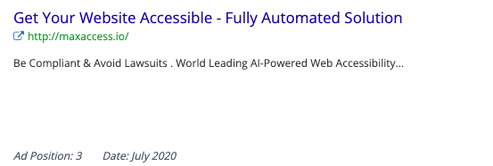

Figure : Fully Automated Solution

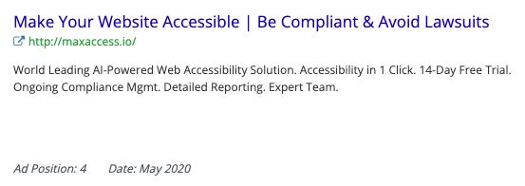

Figure : Be Compliant & Avoid Lawsuits

In addition to using the now all-too-familiar tactic of “protect[ing] your business from lawsuits,” this particular ad demonstrates the company’s unfamiliarity with actual accessibility by using the incorrect term “Alt-Tag”:

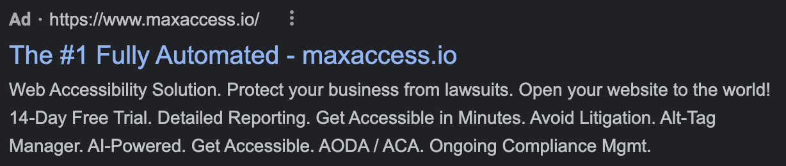

Figure 63: The #1 Fully Automated

# Purple Lens

Address: Tel Aviv, Israel

Website: <https://purple-lens.com>

“We are a team of entrepreneurs, web-developers, UX/UI designers and physicians based in Israel. We are dedicated to finding a solution that makes websites more usable for 20% of online users in order to create equal opportunities.

For years, web accessibility has been an issue for almost any type of online business that struggled to gain new visitors and customers. A majority of sites work on WordPress and since the Israeli legal requirements for website inclusivity are particularly strict, we set a goal to make all WordPress sites accessible, whatever it takes.

We invested a huge amount of time and energy, eventually creating today’s most advanced solution. Our assistive technology has been implemented in numerous projects for the Israeli Government and multiple local businesses. Today, thousands of Israeli websites use our assistive technology and now we are ready to go global.”

(<https://purple-lens.com>)

## Evidence from Website

The company claims that its product will allow a personalized UX for “EVERY user” (emphasis theirs) and promises “AA accessibility compliance”: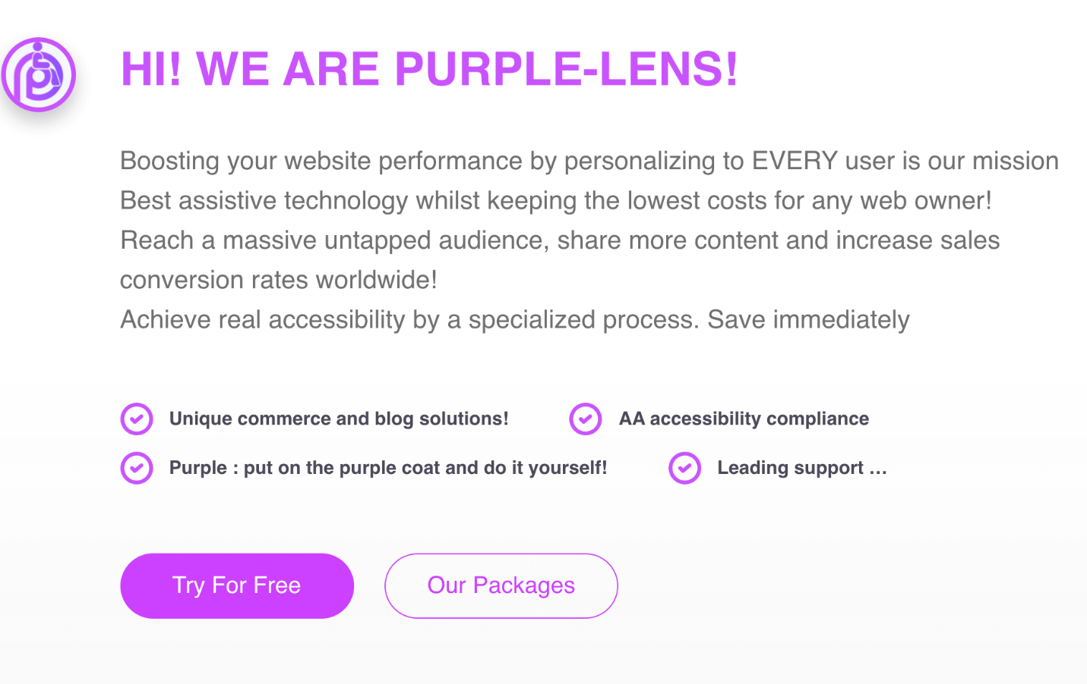

Figure : Hi! We are Purple Lens! (Captured October 25, 2021)

For less than $16 per month, Purple-Lens claims that their product can “Achieve 100% AA Compliance”: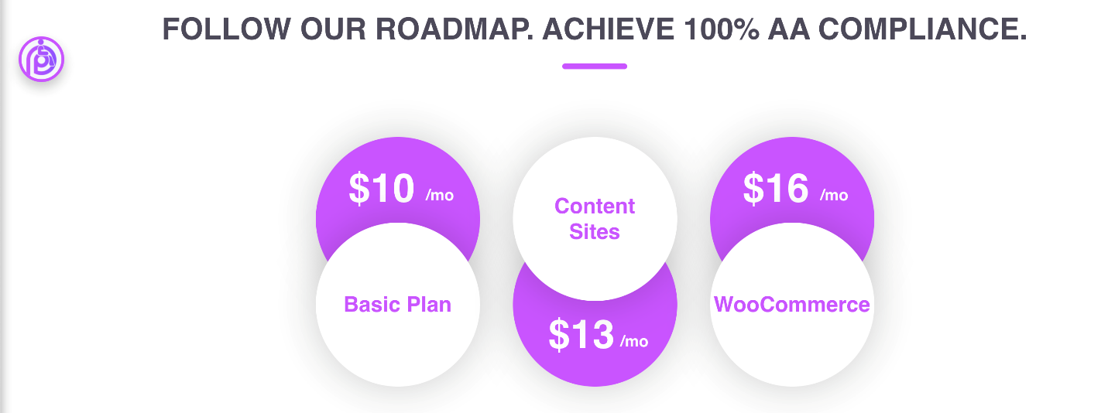

Figure : Follow Our Roadmap (Captured October 25, 2021)

# UserWay

Address: 1007 North Orange St. 10th Floor Wilmington, DE, 1980, USA

Website: <https://userway.org/>

“UserWay creates advanced website accessibility solutions that help ensure ADA compliance without refactoring your website's existing code.

With UserWay's RaaS™ (Remediation as a Service™) technology you can effortlessly increase compliance with WCAG 2.1, ADA, ATAG 2.0, EN 301-549, and Section 508 regulations as required by US & international governmental & regulatory bodies.”  
(<https://userway.org/about/>)

## Evidence from Website

On its website, UserWay claims its solutions “provide full WCAG & ADA compliance from day one” and protects its clients from “accessibility-related lawsuits”:

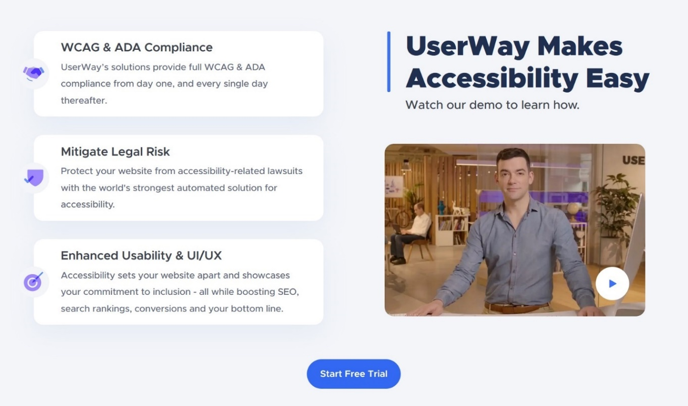

Figure : UserWay Makes Accessibility Easy (Captured October 24, 2021)

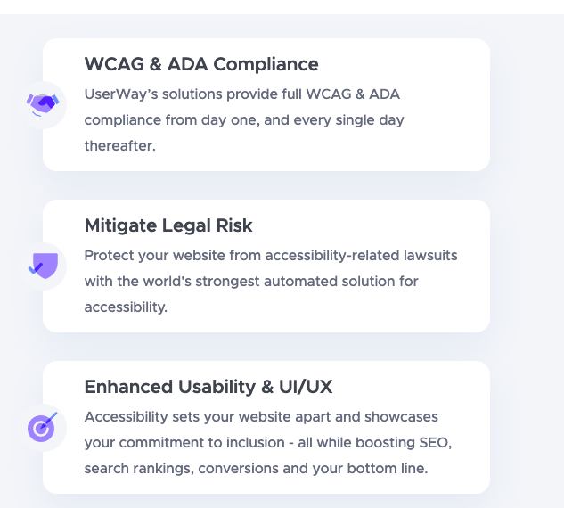

Figure : WCAG & ADA Compliance (Captured October 24, 2021)

The company claims its customers can “avoid lawsuits with only a single line of code” and that their solution is “[t]rusted by more than 1,421,130 websites” and is backed by a $1 million guarantee:

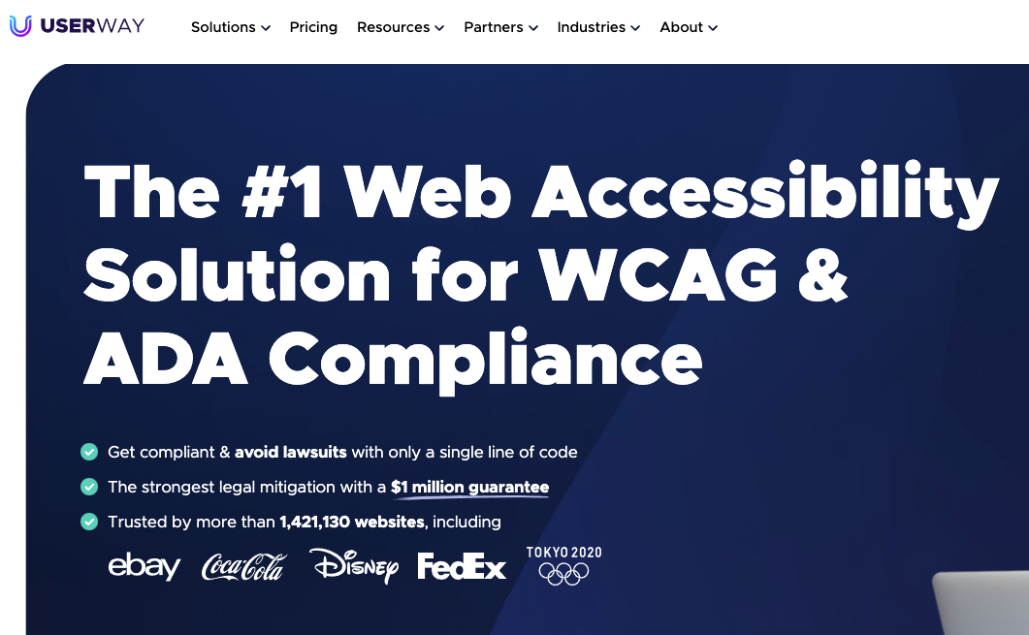

Figure : The #1 Web Accessibility Solution

UserWay’s website also uses the familiar legal scare tactics:

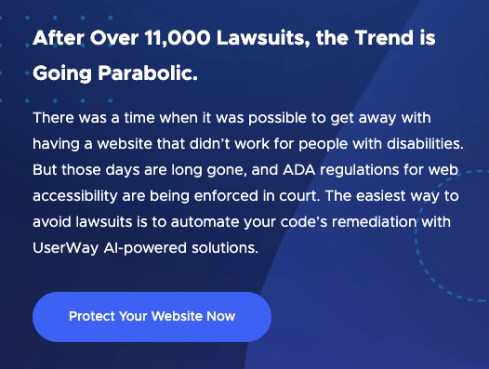

Figure : The Trend is Going Parabolic

The FAQ section of the website also claims the product “provides full ADA and WCAG 2.1 compliance”:

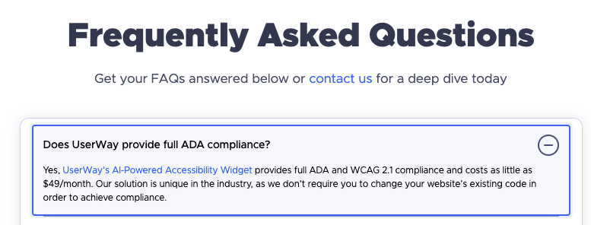

Figure : Does UserWay provide full ADA compliance? (Captured October 24, 2021)

The FAQ also claims that using UserWay’s widget, a client will “luckily” not need their assistance with demand letters or lawsuits (which itself seems to undermine its claims to protect against them), but in the case a client does receive such a legal challenge, UserWay will provide what we consider a legally useless “Statement of Compliance” as proof of a site’s accessibility:

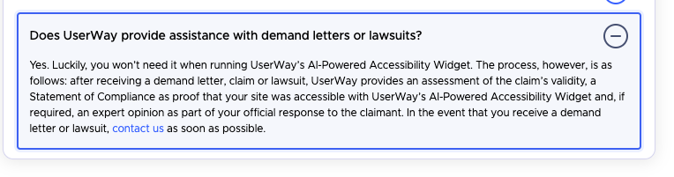

Figure : Does UserWay provide assistance with demand letters or lawsuits? (Captured October 24, 2021)

## Evidence from Email

In their direct marketing emails, UserWay promises that their widget gives “**full** (emphasis theirs) WCAG coverage” and can make a site “completely ADA-compliant”:

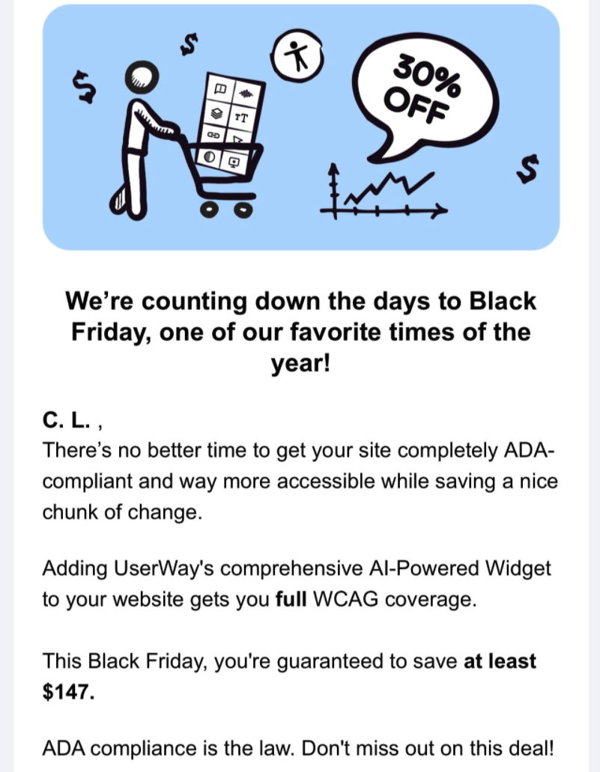

Figure : Black Friday Deal (received and captured November 19, 2021)

## Evidence from Twitter

UserWay makes the bold claim that its screen reader is better than “standard screen readers” because it “is engineered specifically for websites”:

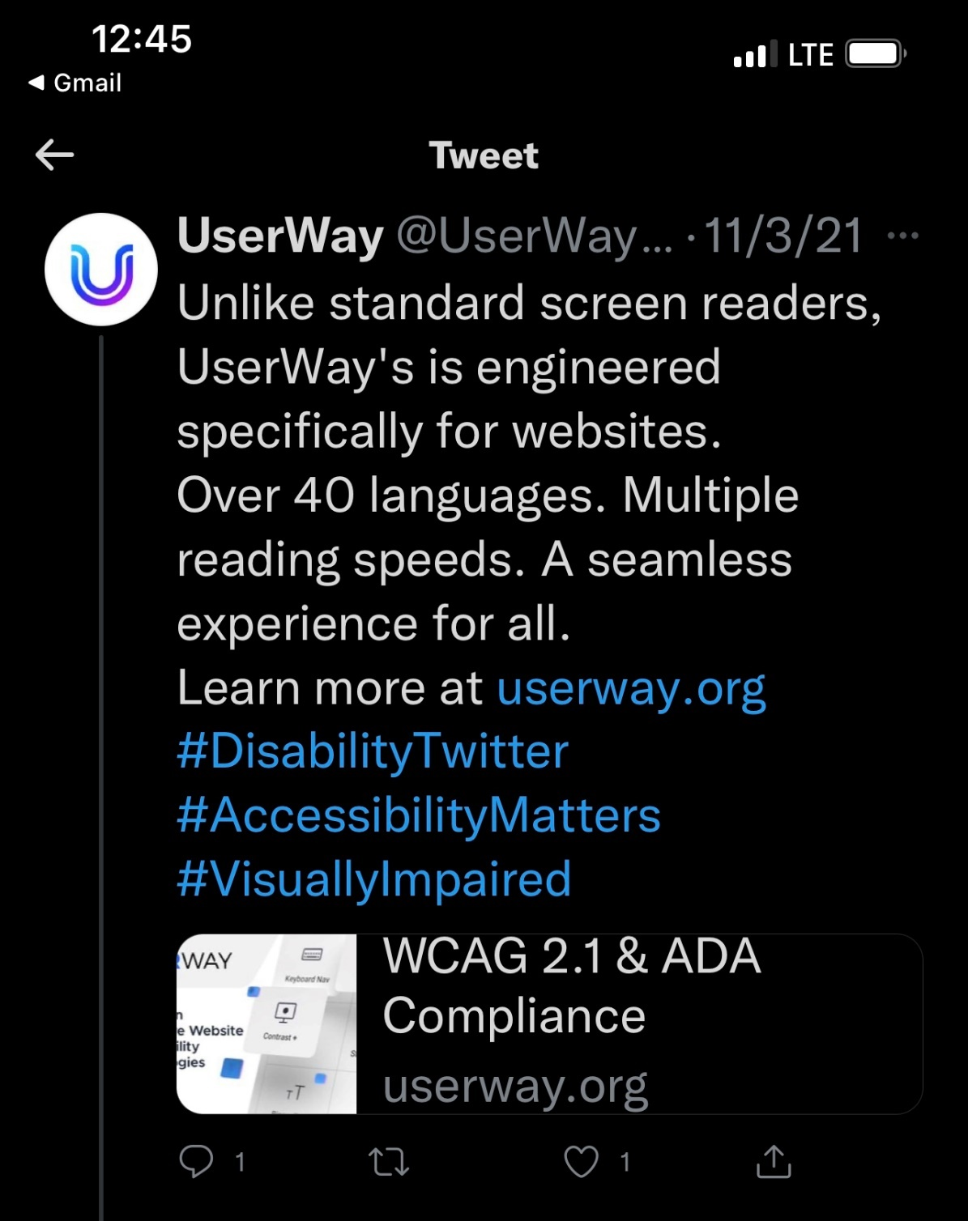

Figure : UserWay's Screen Reader (Captured on November 3, 2021)

## Evidence from Facebook

<https://www.facebook.com/UserWay>

On Facebook, the company claims that it can magically make all sites compliant “in a flash”:

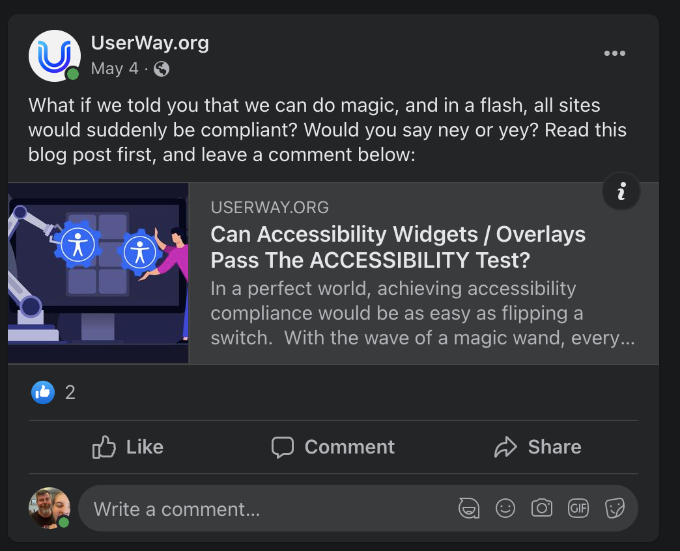

Figure : Can Overlays Pass the Accessibility Test? (Captured October 24, 2021)  
<https://www.facebook.com/UserWay/posts/2906487569592368>

UserWay continues to push the “one line of code” solution as a viable one:

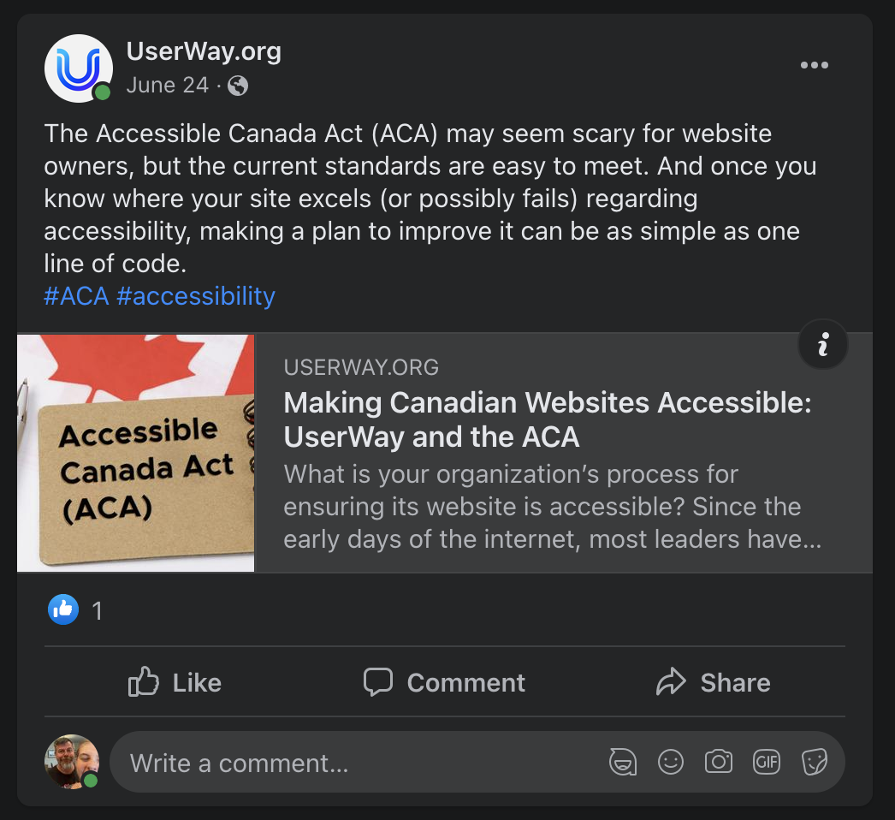

Figure : Accessible Canada Act  
<https://www.facebook.com/UserWay/posts/2942545285986596>

For e-commerce platforms, the company claims that its product will make their sale prices “automatically…accessible”. Ironically, the linked video does not have an audio description so is, itself, inaccessible to screen reader users:

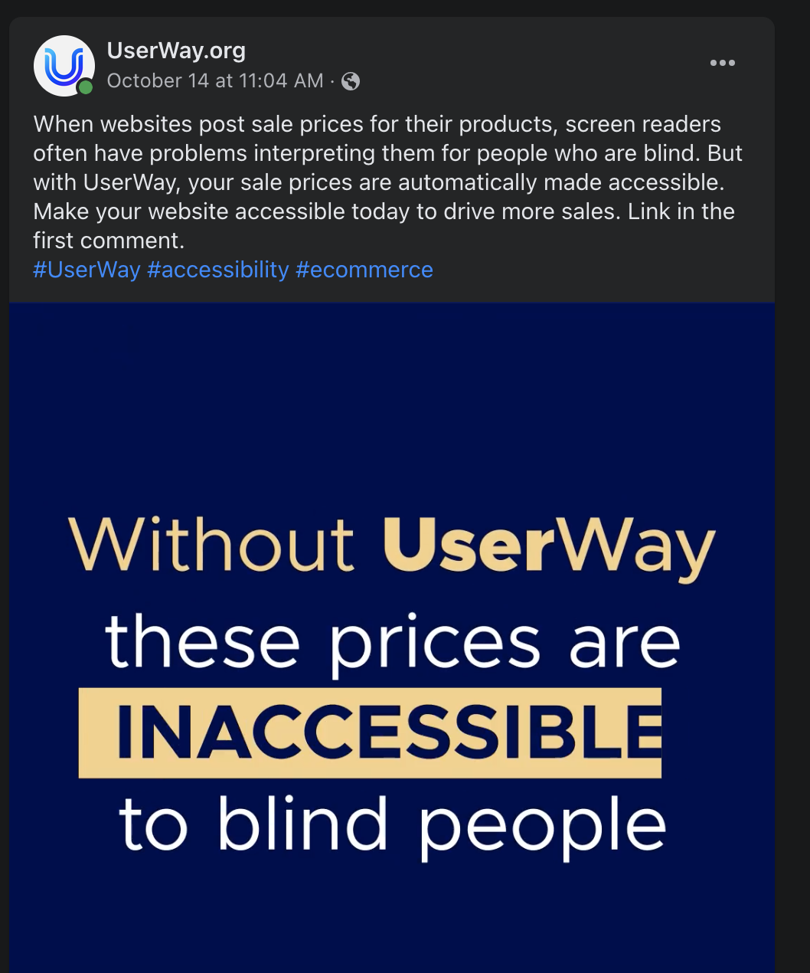

Figure : Sale Prices  
<https://www.facebook.com/UserWay/videos/295124915776001/>

The company claims its product will make “all the [color contrast] customization options” with one click:

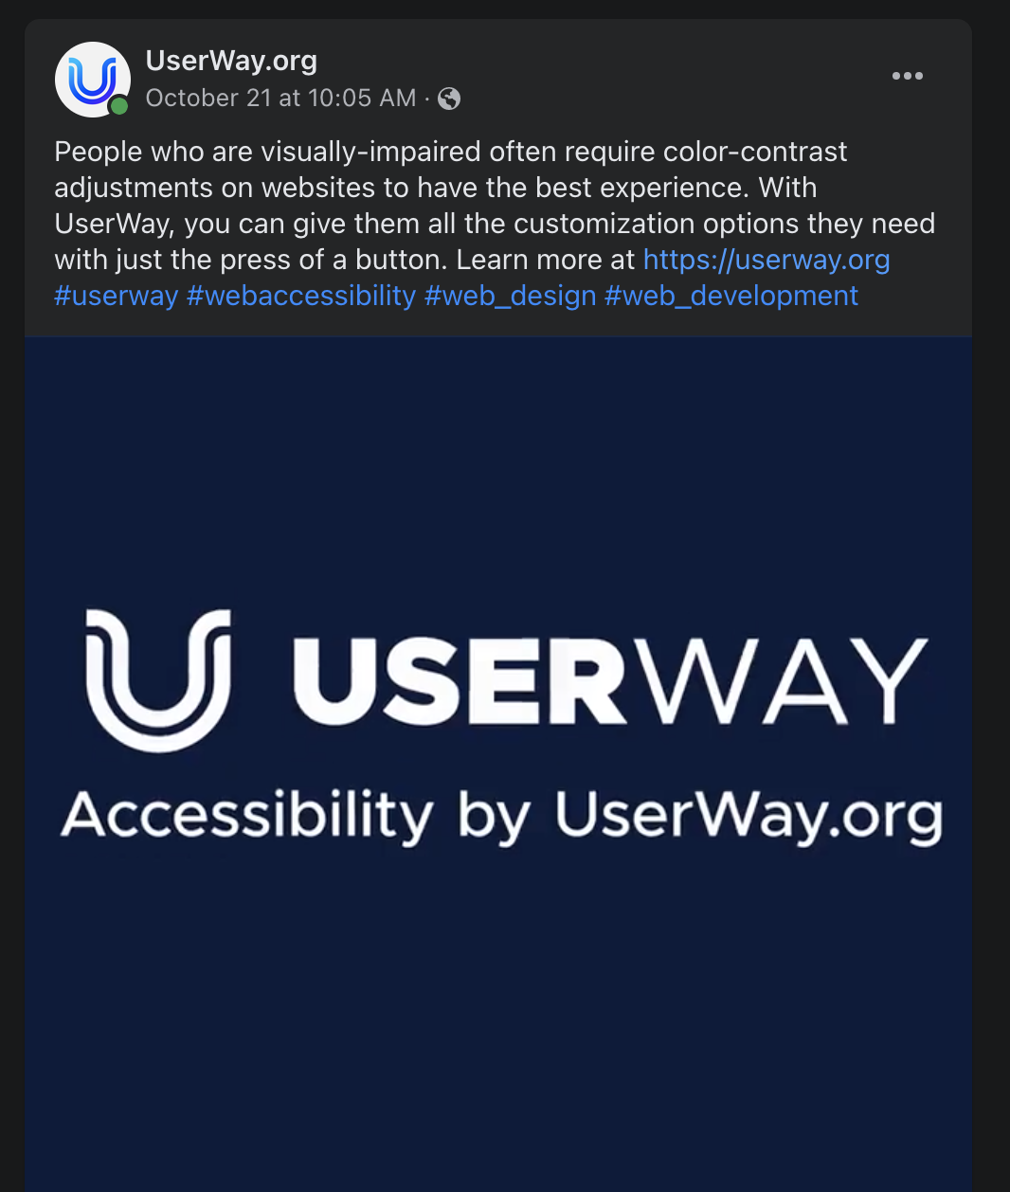

Figure : Color Contrast Adjustments  
<https://www.facebook.com/UserWay/videos/3034451863468844/>

The company also claims its product can be beneficial to Shopify store owners and “ensure their shops are inclusive”:

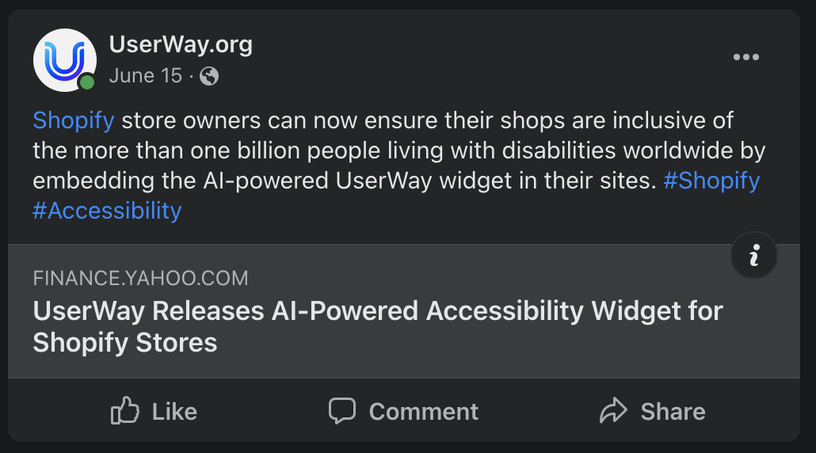

Figure : Shopify Widget (Captured on October 24, 2021)  
<https://www.facebook.com/UserWay/posts/2906487569592368>

## Evidence from Google Ads (source: SpyFu.com)

UserWay spends an estimated $6057 on CPC ads per month.

15% of the UserWay website traffic comes from CPC ads

On its Google Ads, UserWay claims that “ADA & WCAG 2.1 Compliance” can be achieved with “No Changes to Your Website’s Code.”

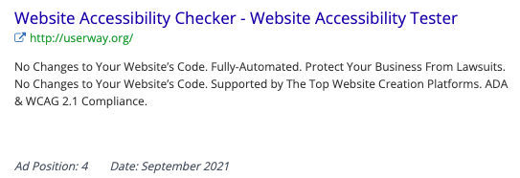

Figure : Google ad (Captured September 2, 2021)

These ads continue peddles the lie that “ADA & WCAG compliance” can be achieved with “[n]o changes to your website’s code”:

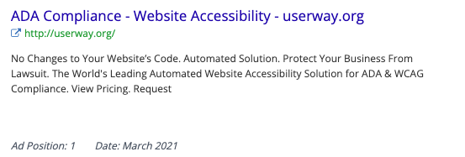

Figure : ADA Compliance - Website Accessibility (Captured September 2, 2021)

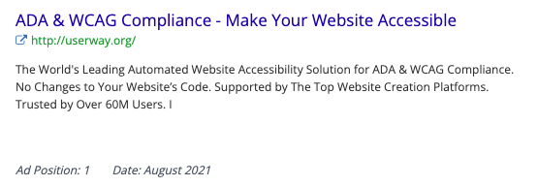

Figure : ADA & WCAG Compliance (Captured September 2, 2021)

The company also touts that its “powerful AI” can fix inaccessible sites automatically:

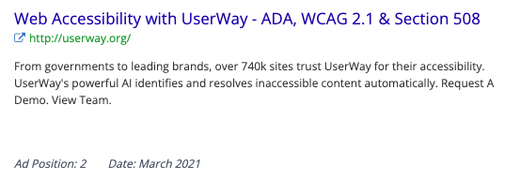

Figure : ADA, WCAG 2.1 & Section 508 (Captured September 2, 2021)

UserWay claims its solution can protect its clients’ “business from lawsuit[sic]” make a website “Lawsuit-Free” with the familiar “no changes to your website’s code” line:

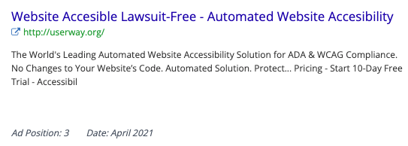

Figure : Lawsuit-Free (Captured September 2, 2021)

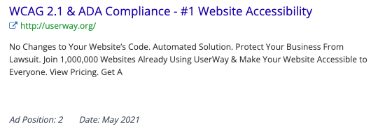

Figure : #1 Website Accessibility (Captured September 2, 2021)

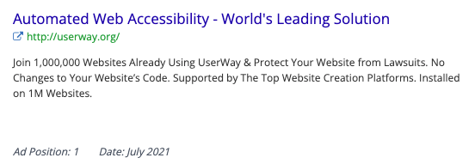

Figure : Automated Web Accessibility

## Evidence of other anti-competitive behavior

UserWay’s widget interferes with automated web accessibility tools such as WAVE, even pointing the user to using the company’s own “UserWay Inspector” instead of whichever tool the user chooses:

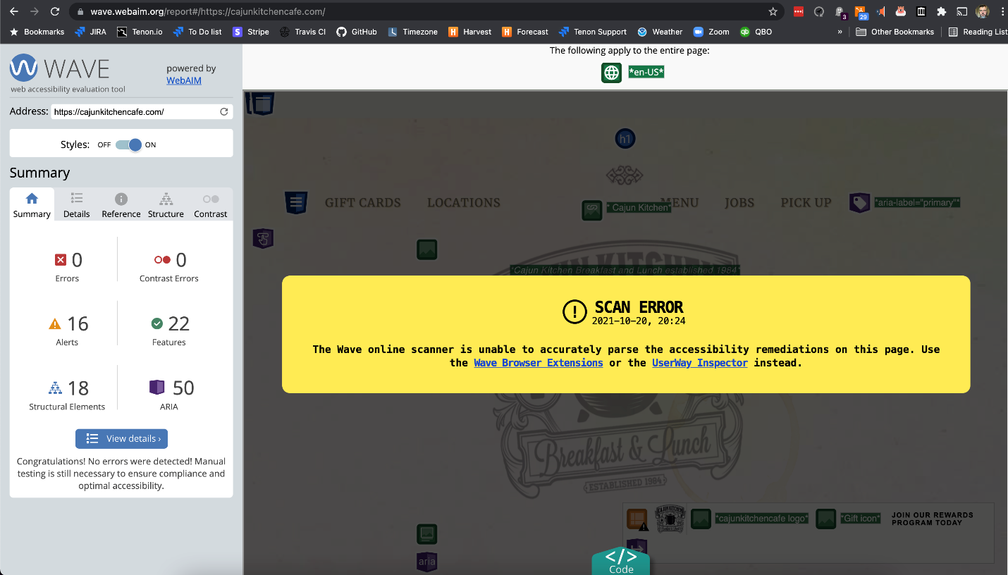

Figure : UserWay - WAVE Scan Error (Captured October 20, 2021)